**HDFC Net Banking Jira tool Screenshots**

I have derived 94 test cases for HDFC Net Banking Project in excel Sheet.

Splited the 94 Test cases into 5 Epics and 10 User Stories. Added Sub-task into the main 10 user Stories.

Attaching the JIRA Screenshots of that below,

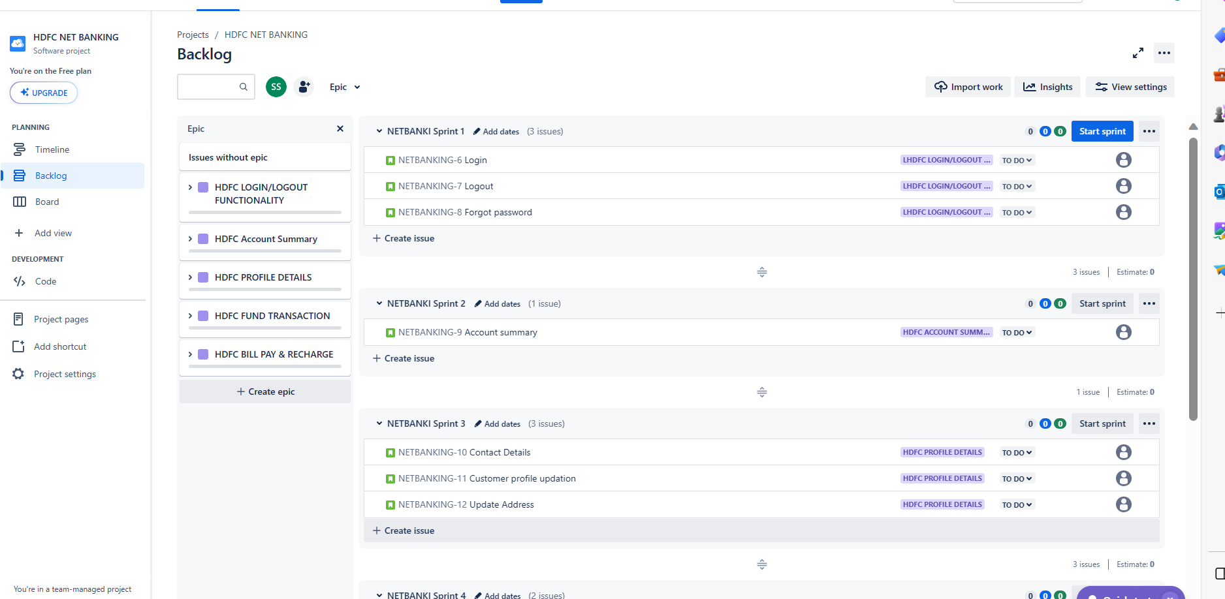

**Sprint1:NetBankSprint1**

**EPIC1: HDFC LOGIN/LOGOUT Functionality**

**User Story1: Login**

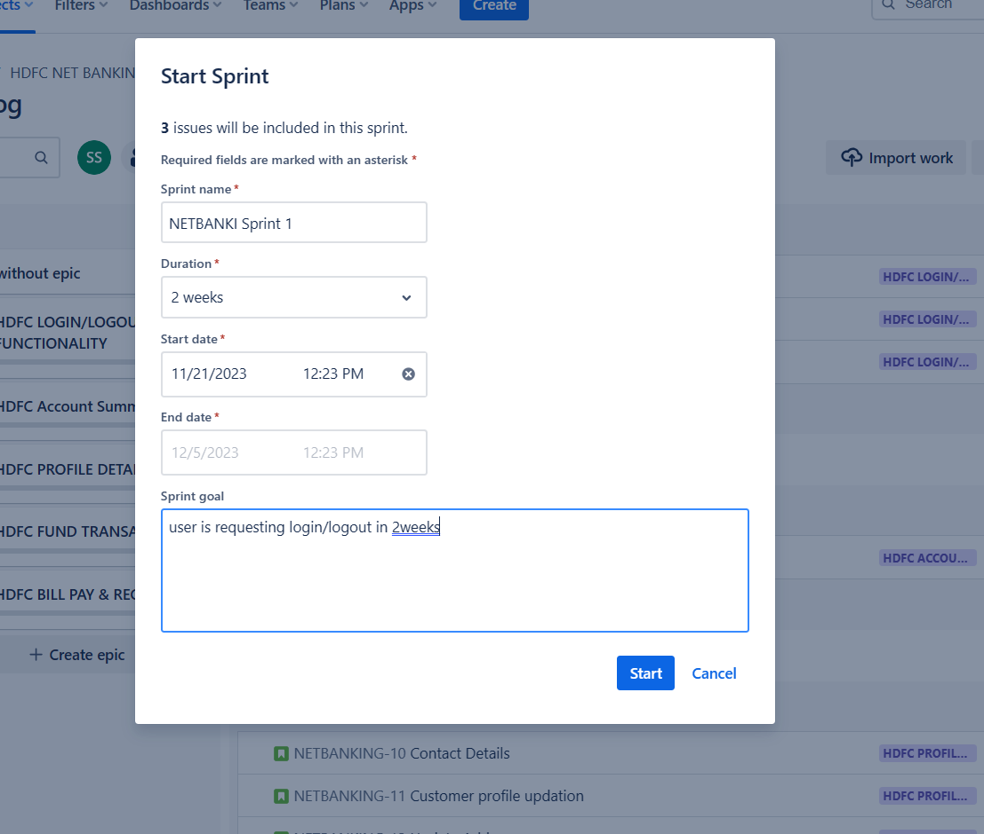

**Evidence:1**

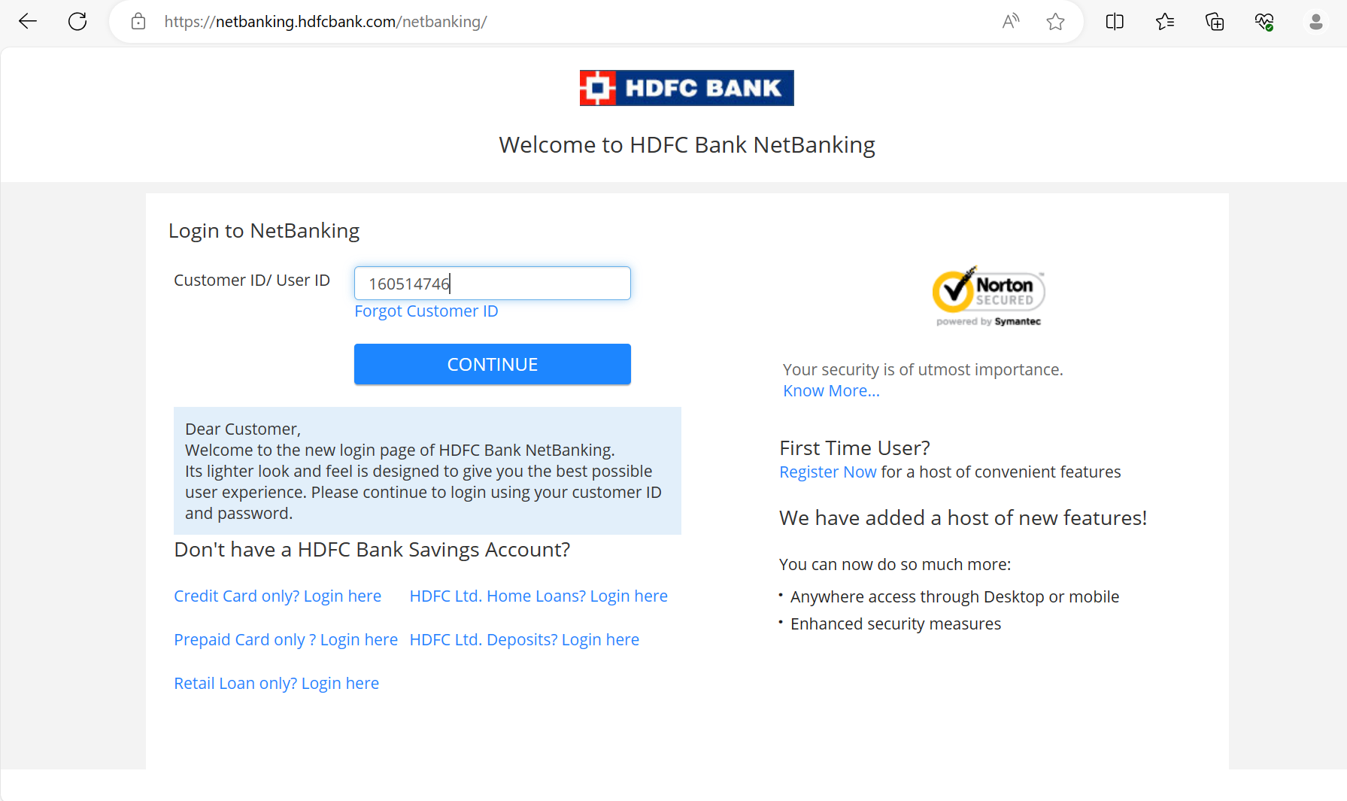

**Evidence:2**

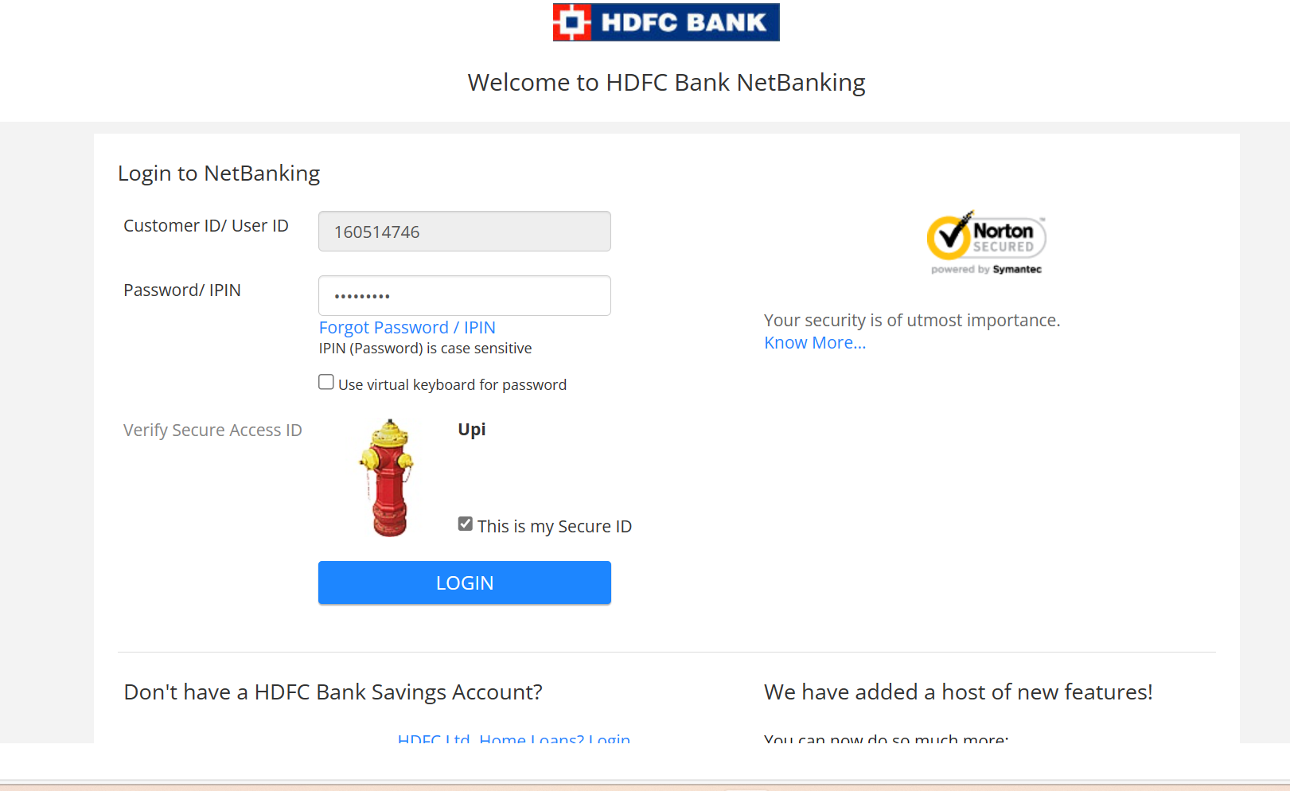

**Sprint1:NetBankSprint1**

**EPIC1: HDFC LOGIN/LOGOUT Functionality**

**User Story1: Login(test data , test description ,acceptance criteria & Actual Result)**

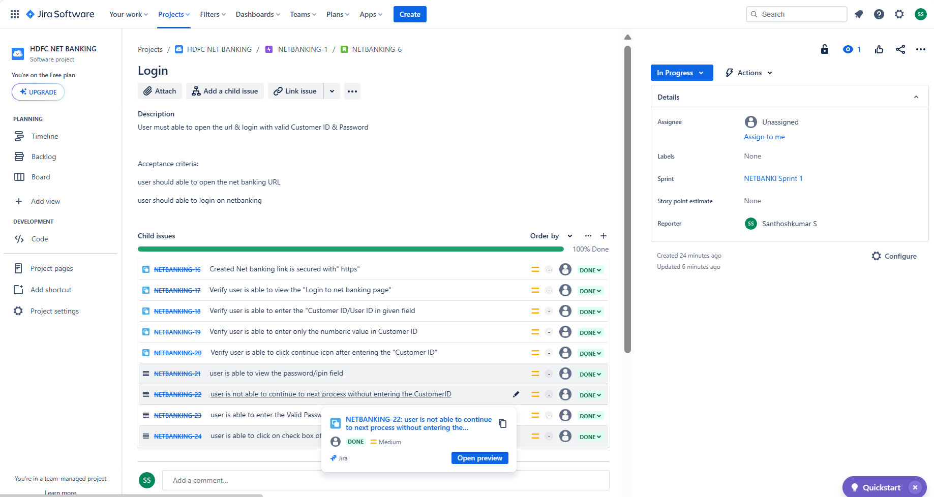

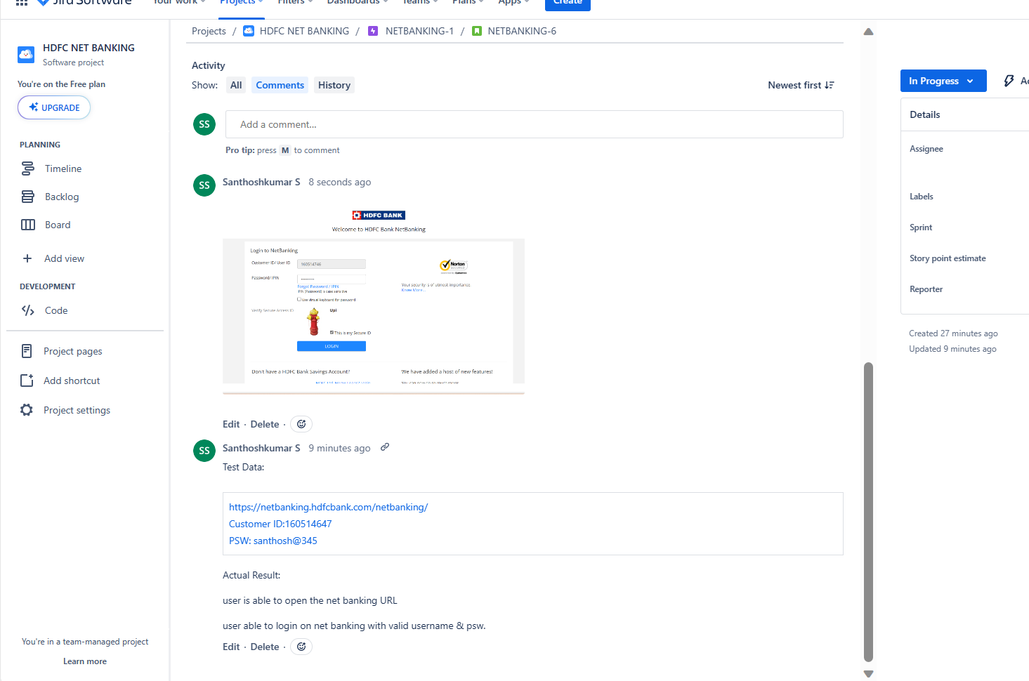

**Sprint1:NetBankSprint1**

**EPIC1: HDFC LOGIN/LOGOUT Functionality**

**User Story2: Logout (test data, test description, acceptance criteria & Actual Result)**

**Evidence1**

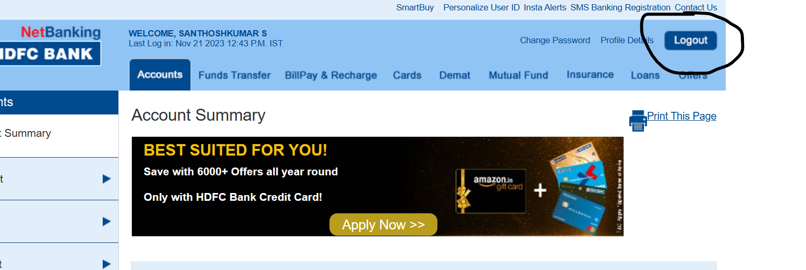

**Evidence2:**



**Sprint1:NetBankSprint1**

**EPIC1: HDFC LOGIN/LOGOUT Functionality**

**User Story2: Logout (test data, test description, acceptance criteria & Actual Result)**

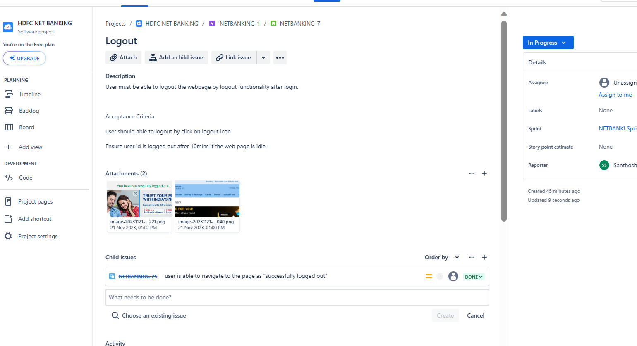

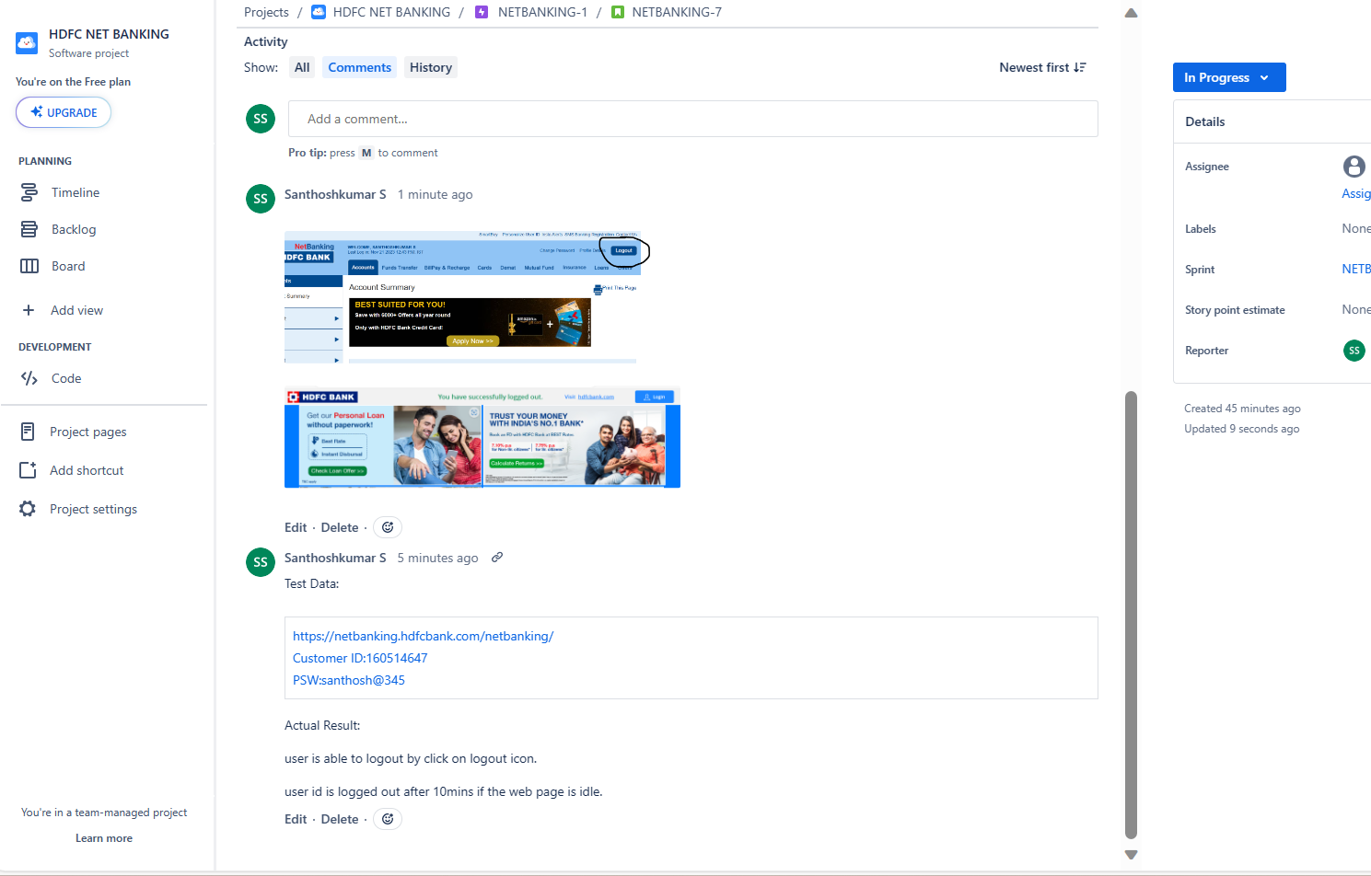

**Sprint1:NetBankSprint1**

**EPIC1: HDFC LOGIN/LOGOUT Functionality**

**User Story3: Forgot Password (test data, test description, acceptance criteria & Actual Result)**

**Evidence1:**

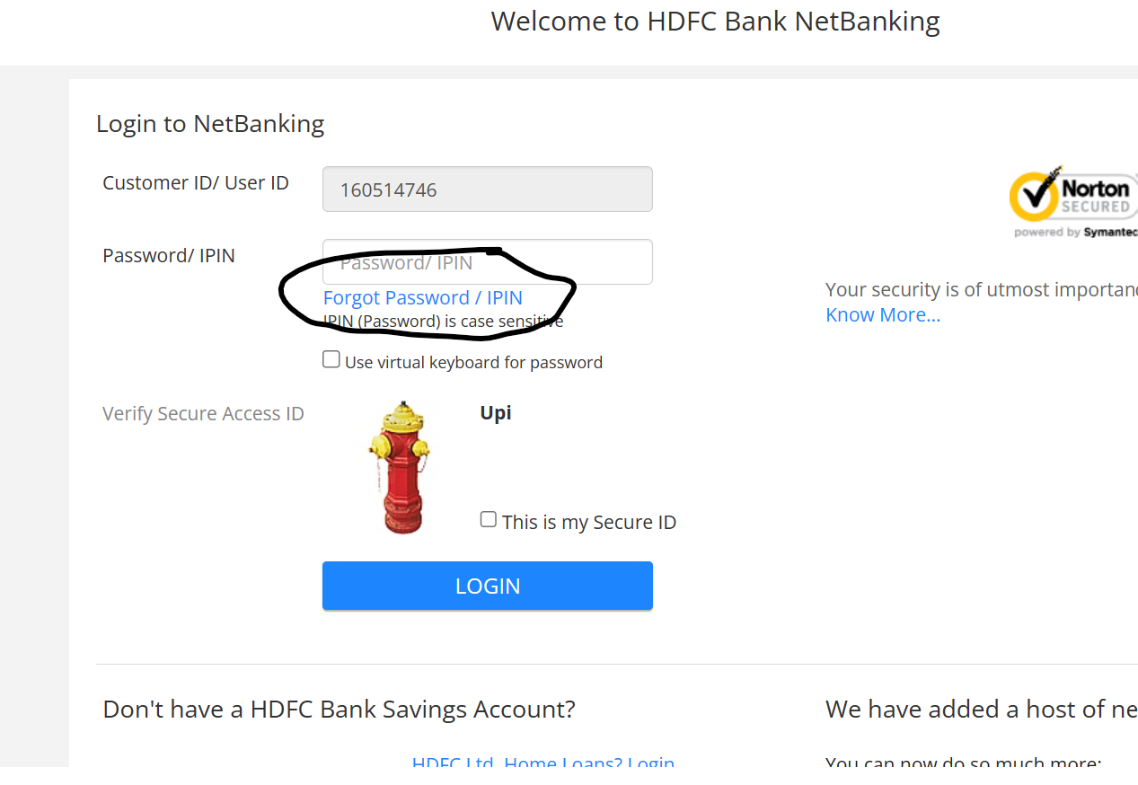

**Evidence2:**

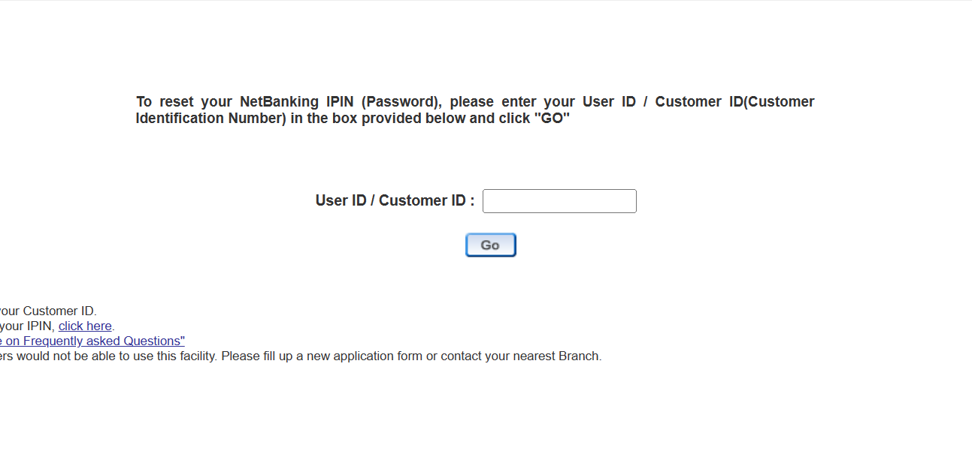

**Evidence3:**

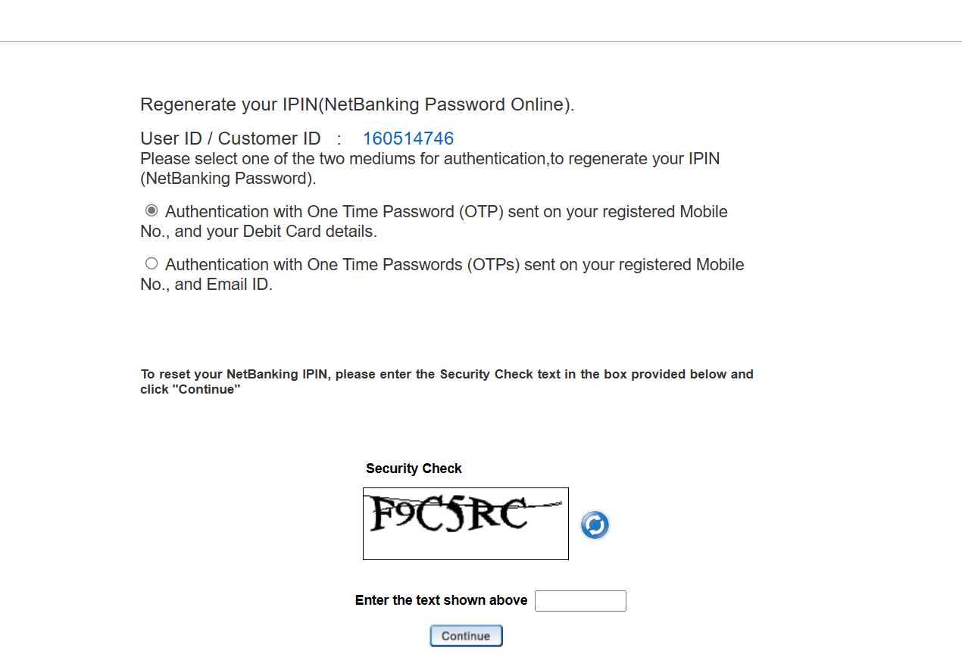

**Sprint1:NetBankSprint1**

**EPIC1: HDFC LOGIN/LOGOUT Functionality**

**User Story3: Forgot Password (test data, test description, acceptance criteria & Actual Result)**

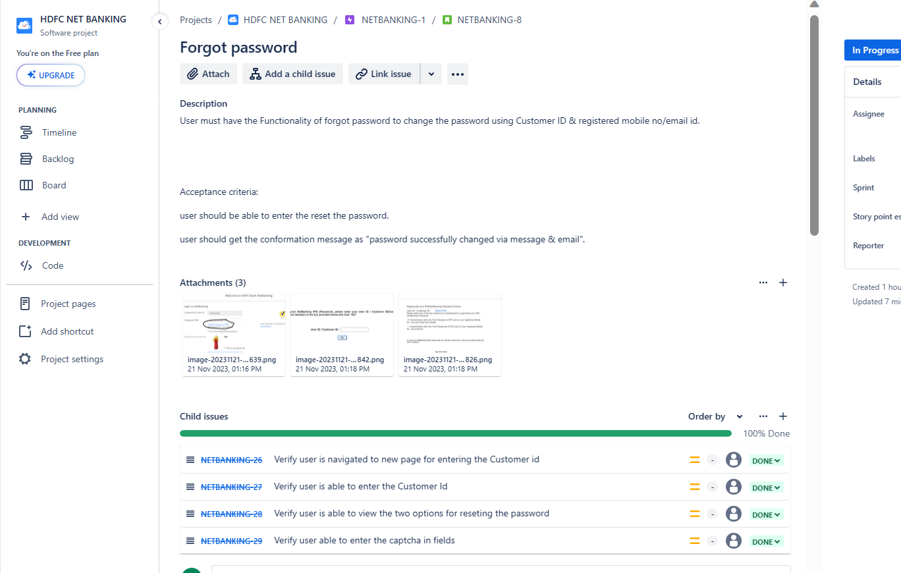

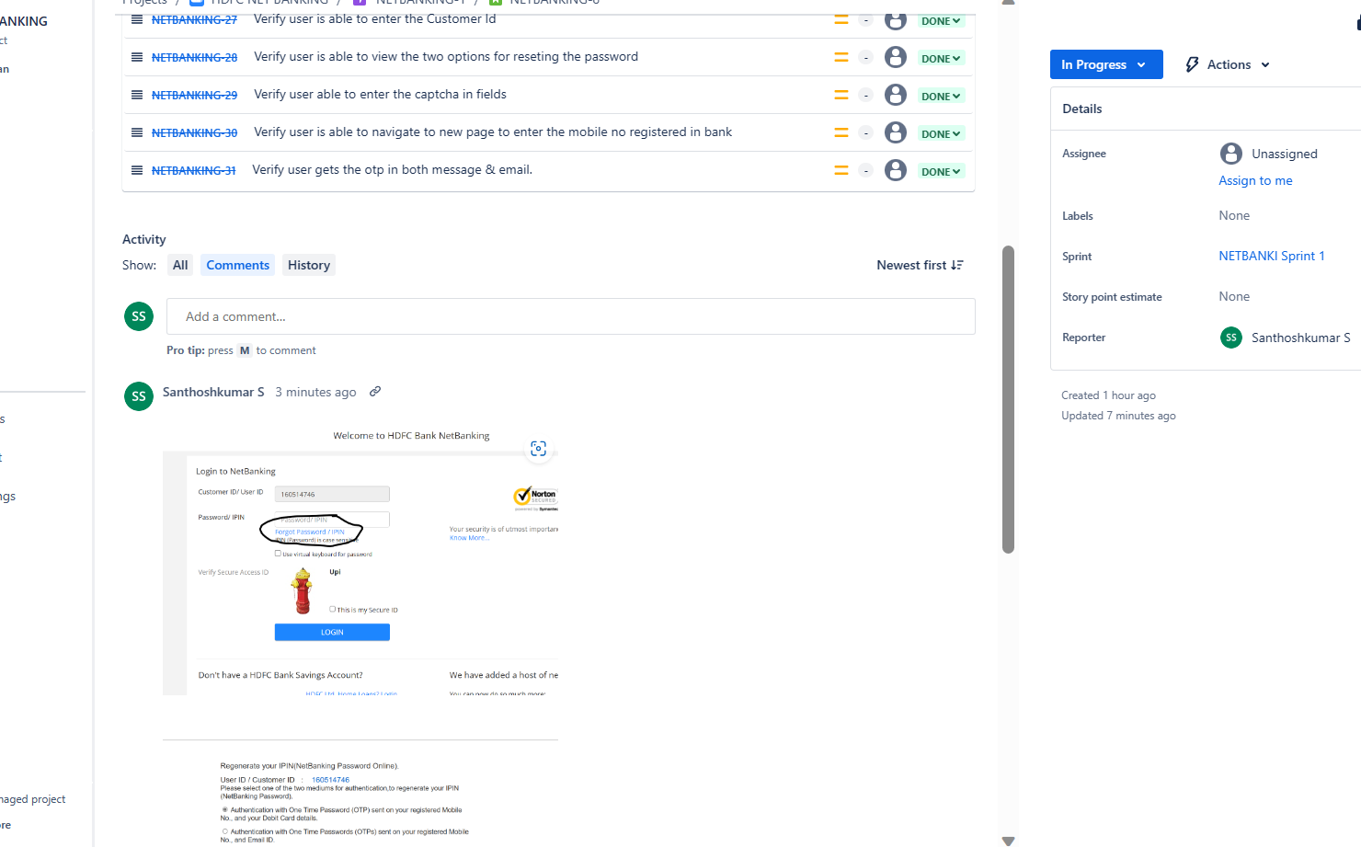

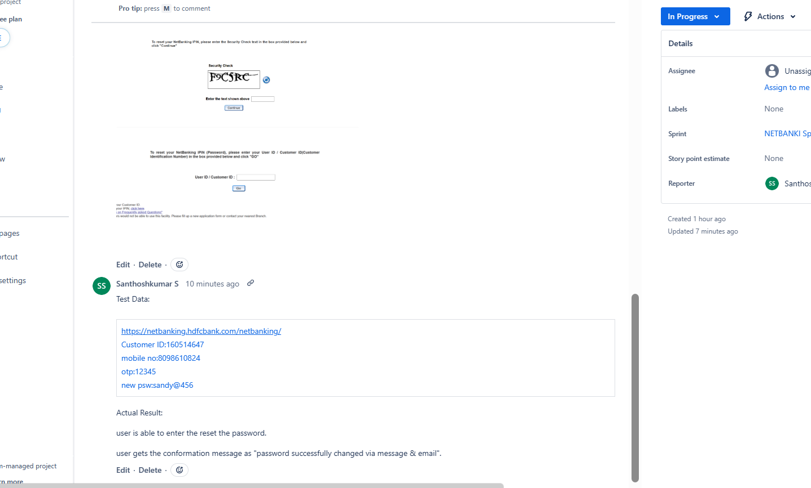

**Sprint1:NetBankSprint1 End of Sprint**

**EPIC1: HDFC LOGIN/LOGOUT Functionality**

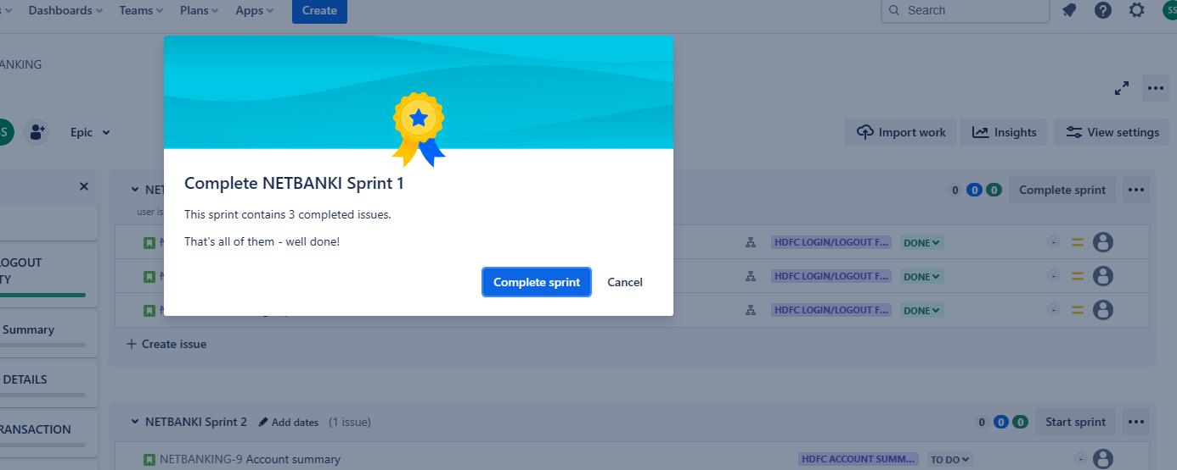

**Sprint3:NetBankSprint3**

**EPIC3: Profile Details Functionality**

**User Story5: Contact Details**

**Evidence1:**

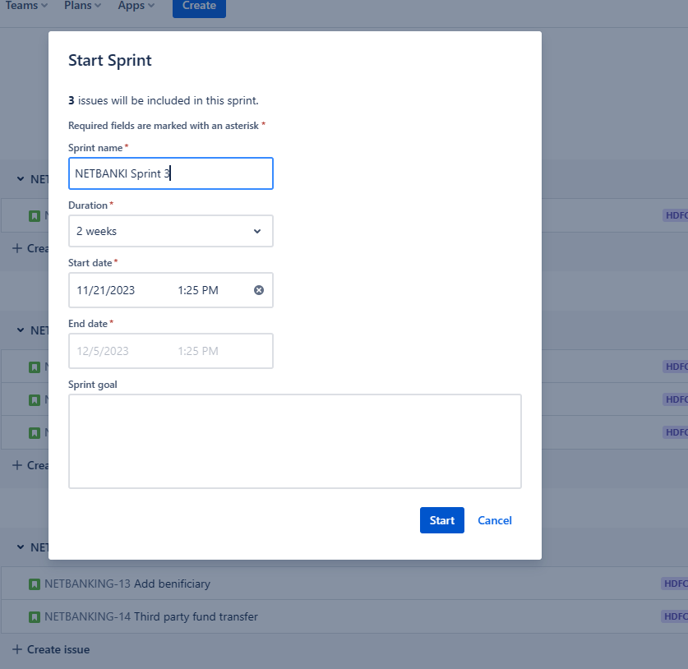

**Evidence2:**

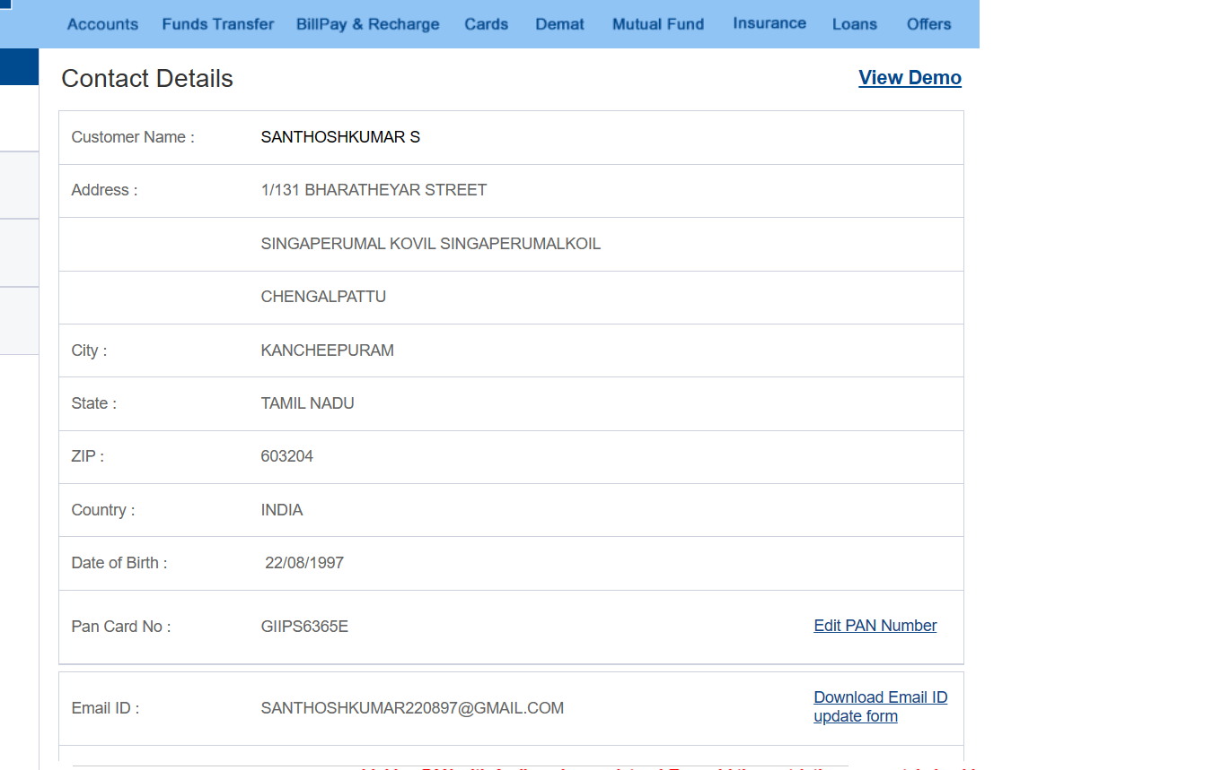

**Evidence3:**

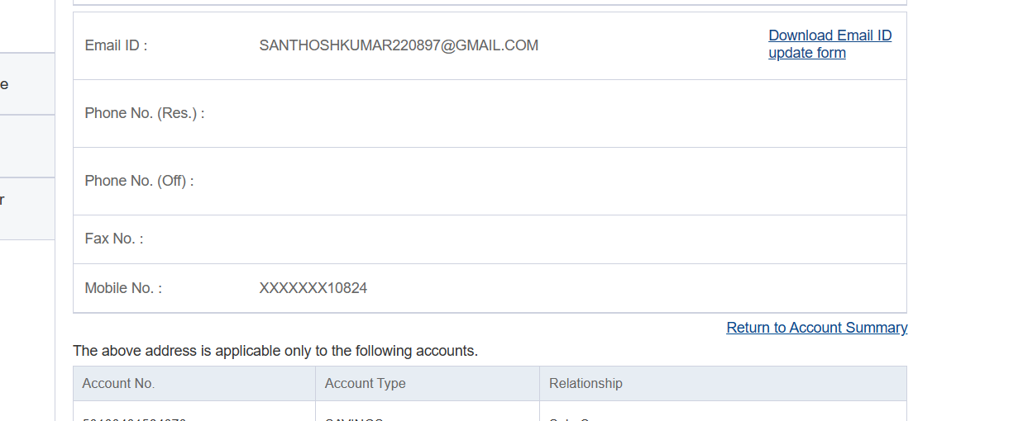

**Sprint3:NetBankSprint3**

**EPIC3: Profile Details Functionality**

**User Story5: Contact Details**

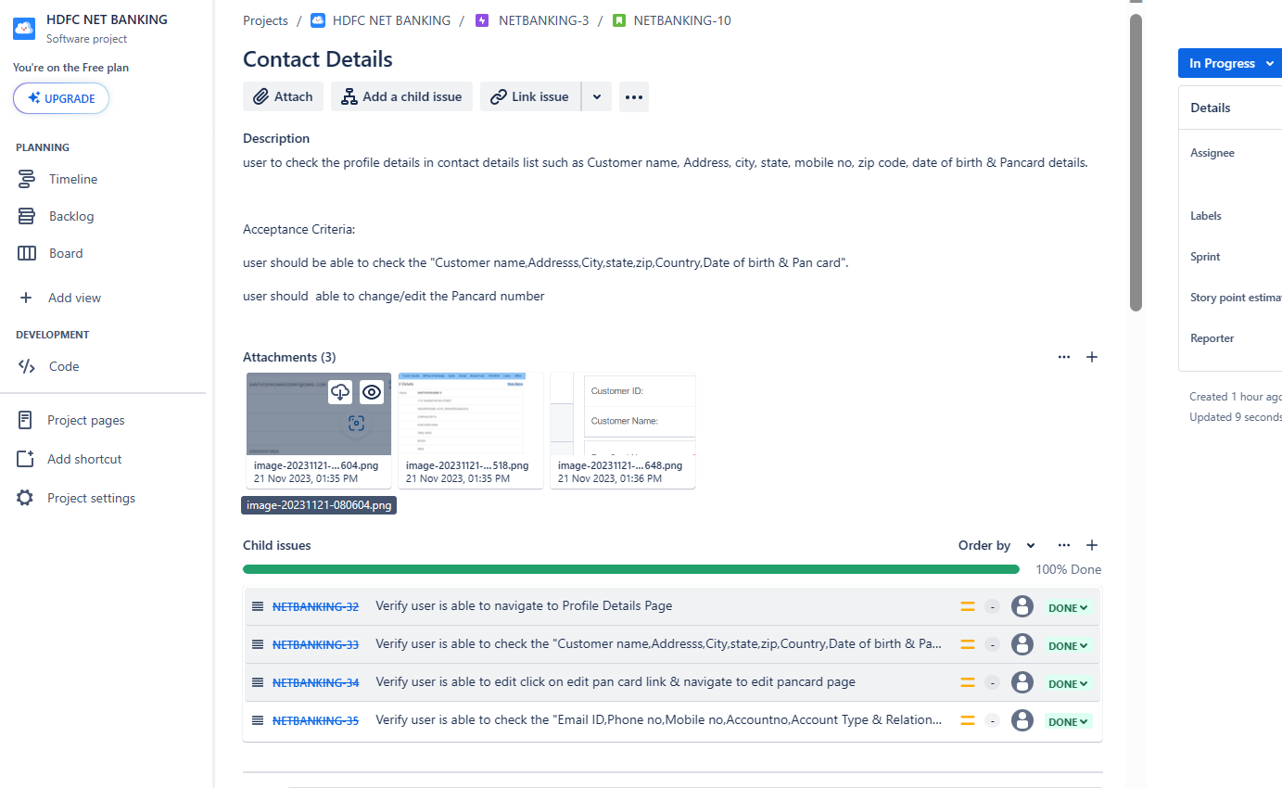

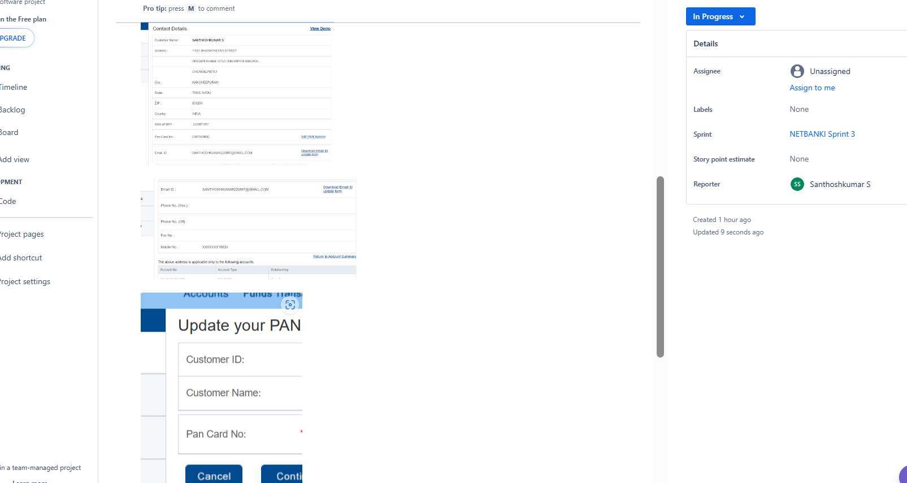

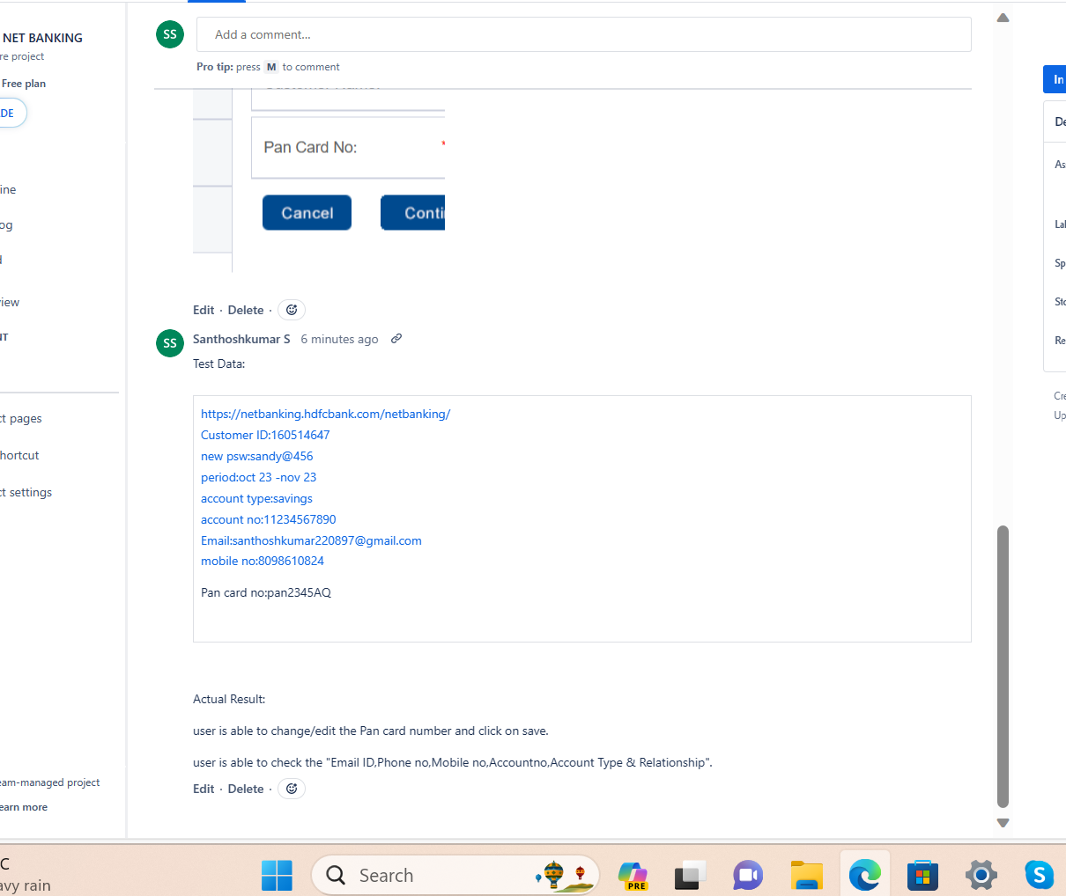

**Sprint3:NetBankSprint3**

**EPIC3: Profile Details Functionality**

**User Story6: Customer profile updation**

**Evidence1:**

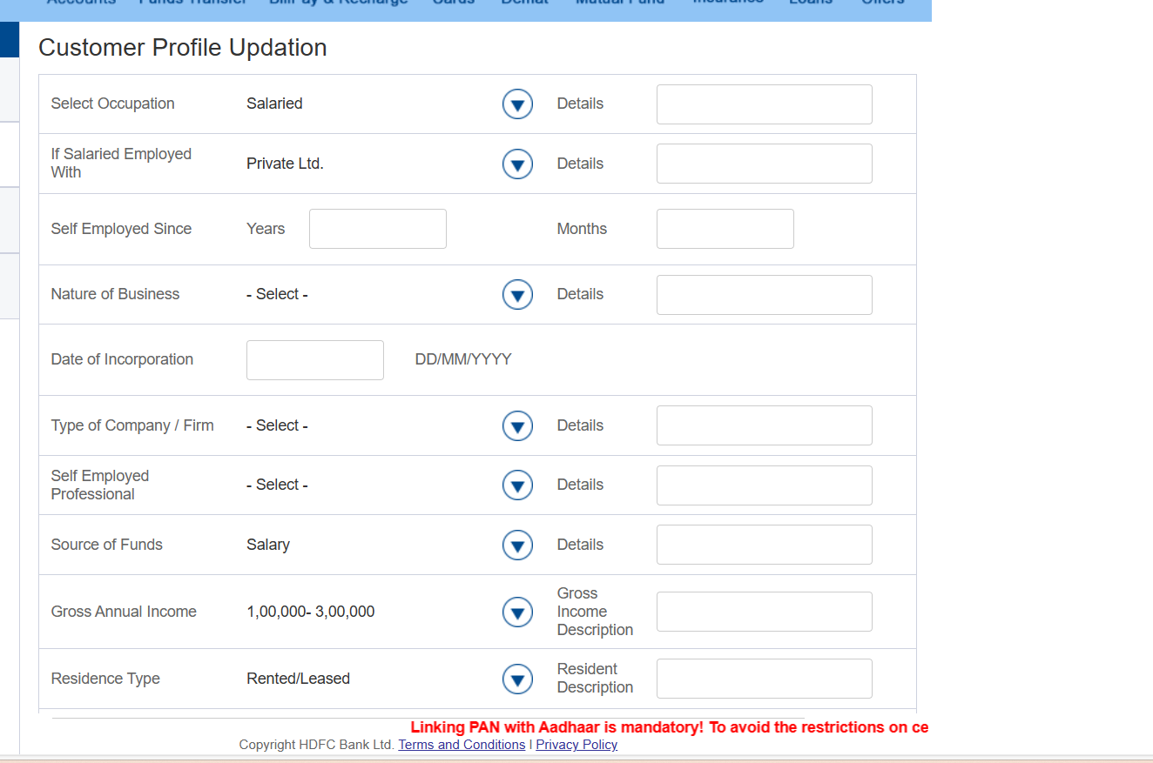

**Sprint3:NetBankSprint3**

**EPIC3: Profile Details Functionality**

**User Story6: Customer profile updation**

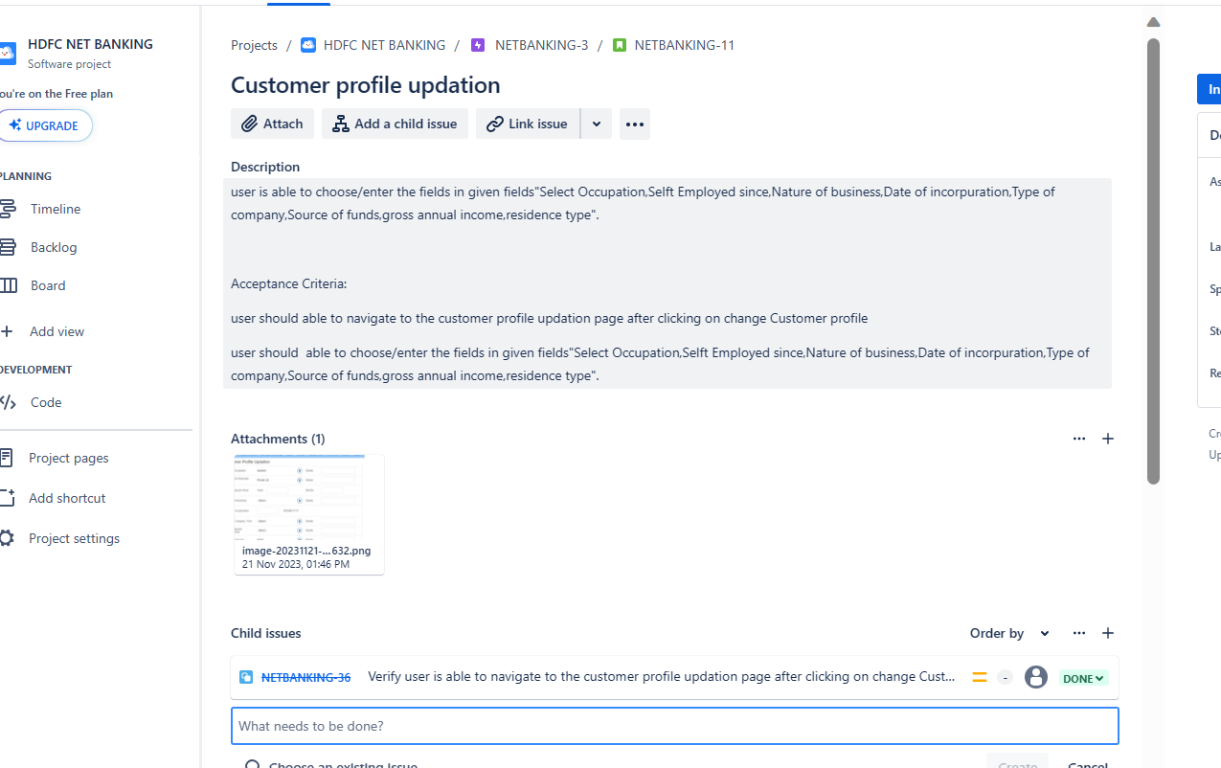

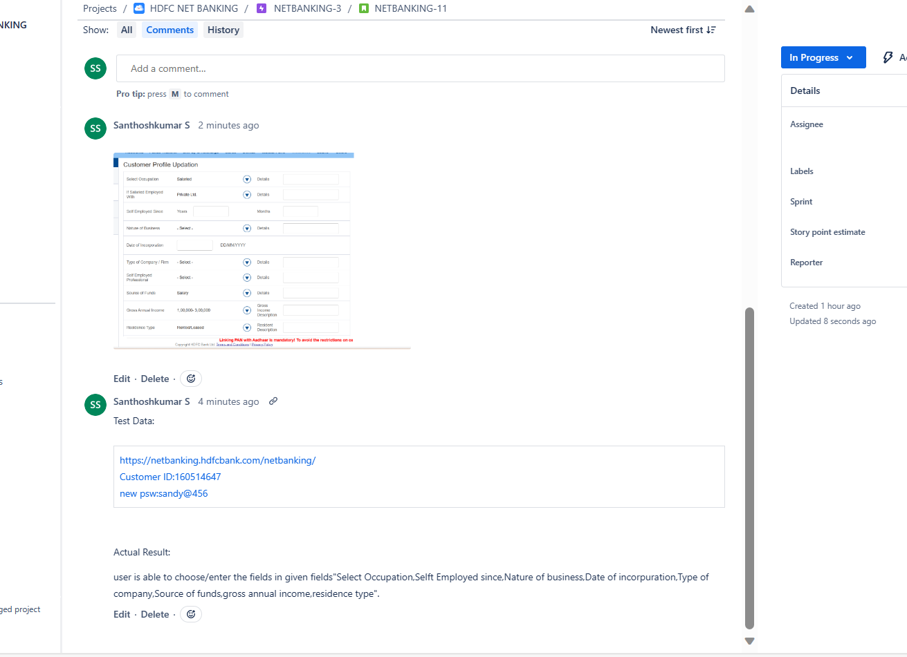

**Sprint3:NetBankSprint3**

**EPIC3: Profile Details Functionality**

**User Story7: Update Address**

**Evidence1:**

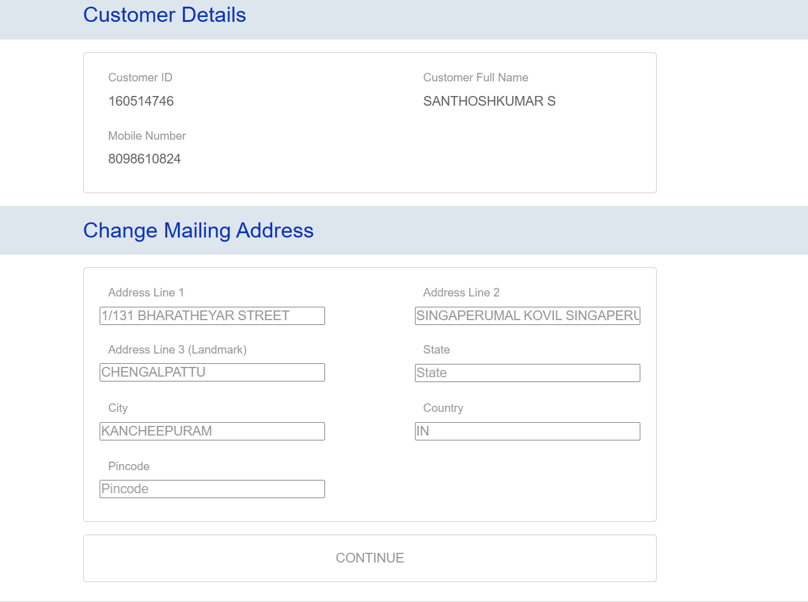

**Sprint3:NetBankSprint3**

**EPIC3: Profile Details Functionality**

**User Story7: Update Address**

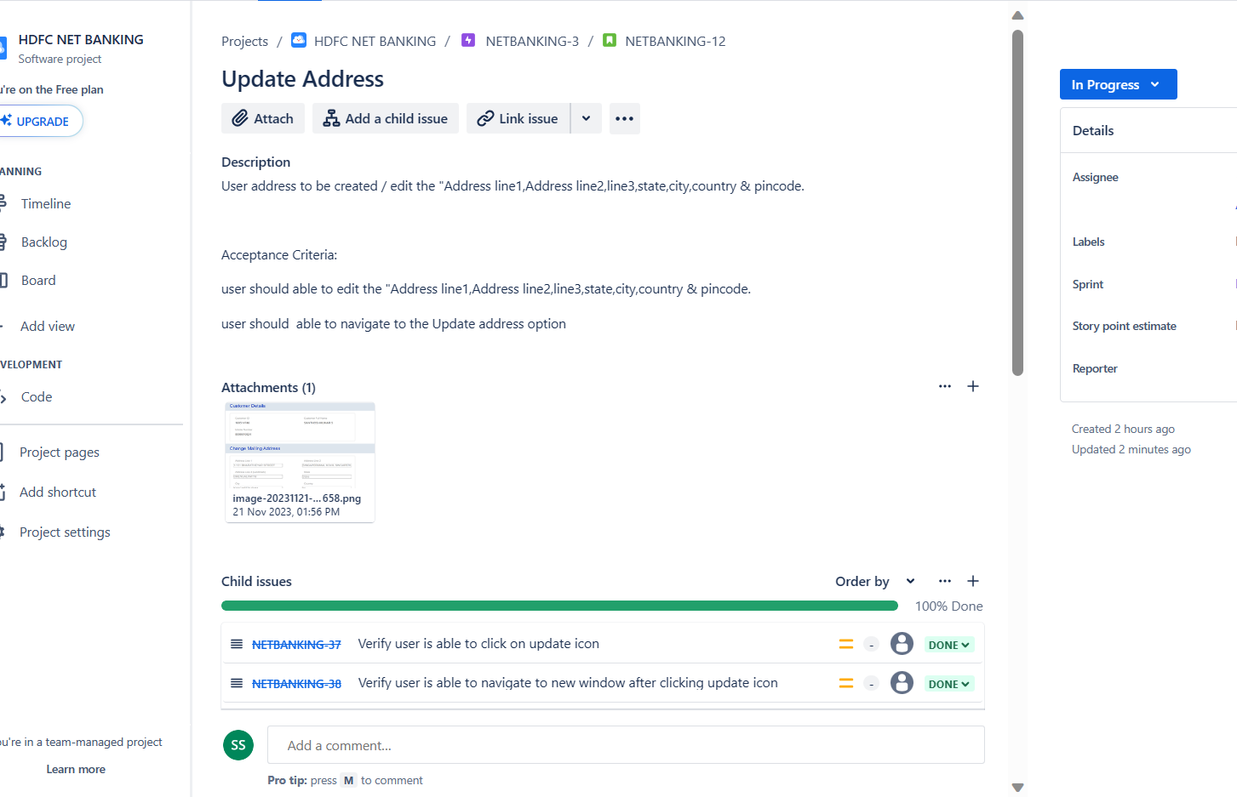

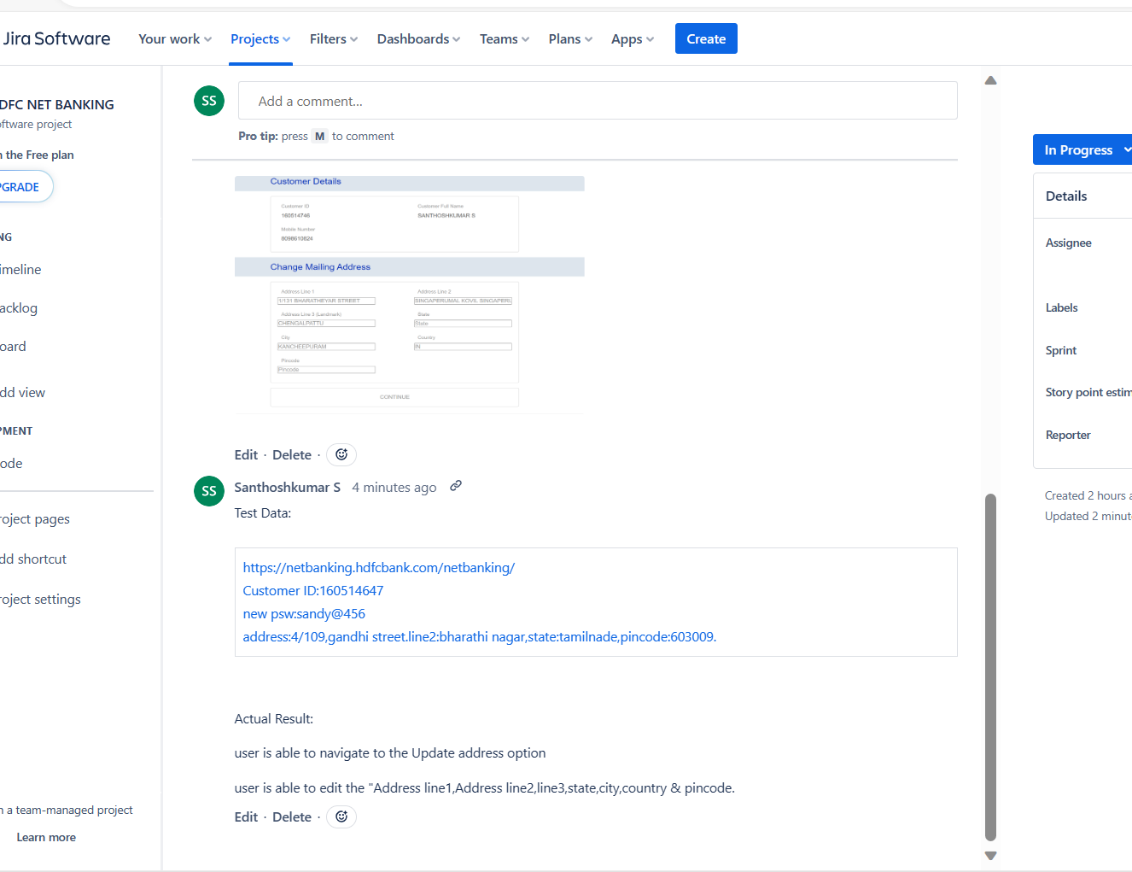

**Sprint3:NetBankSprint3-End of Sprint**

**EPIC3: Profile Details Functionality**

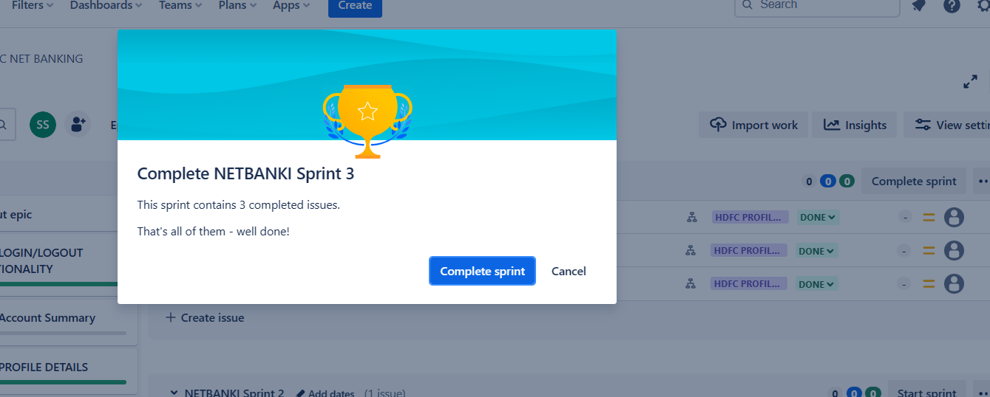

**Sprint2:NetBankSprint2**

**EPIC2: Account Summary**

**User Story4: Account Summary**

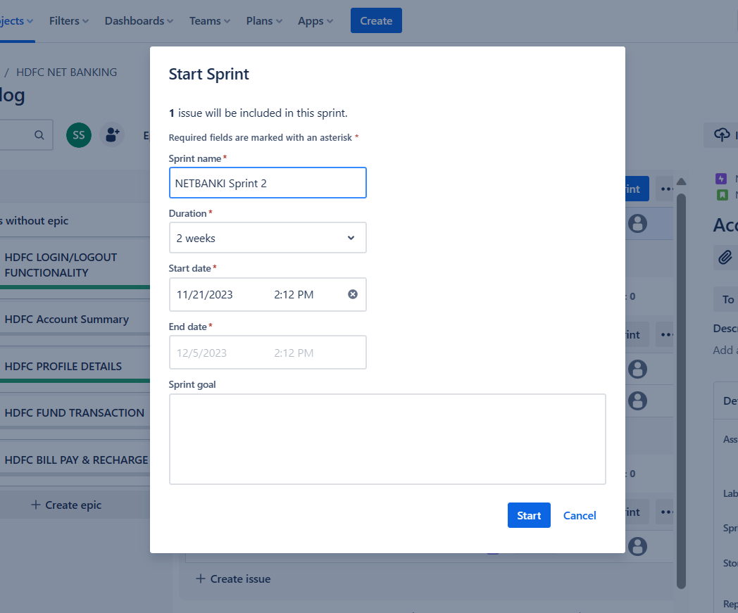

**Evidence1:**

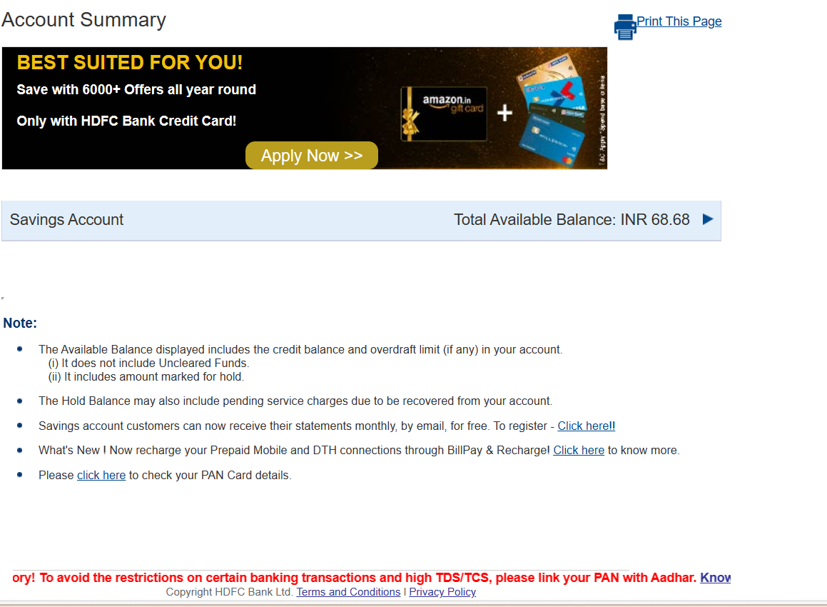

**Evidence2:**

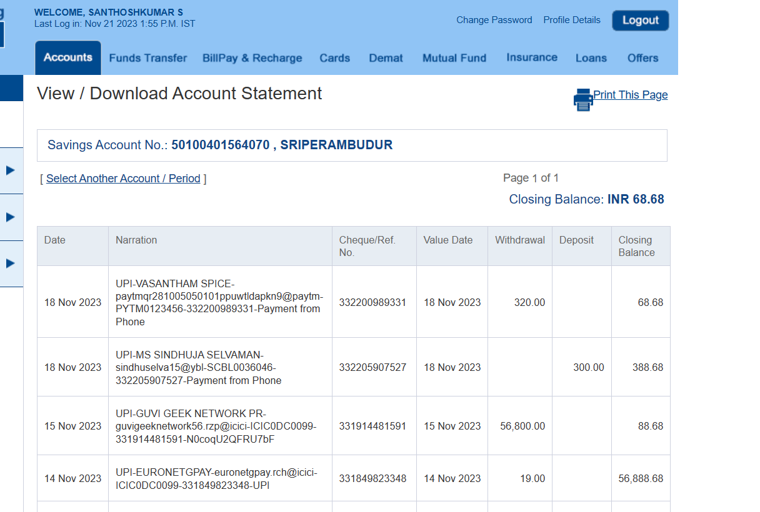

**Sprint2:NetBankSprint2**

**EPIC2: Account Summary**

**User Story4: Account Summary**

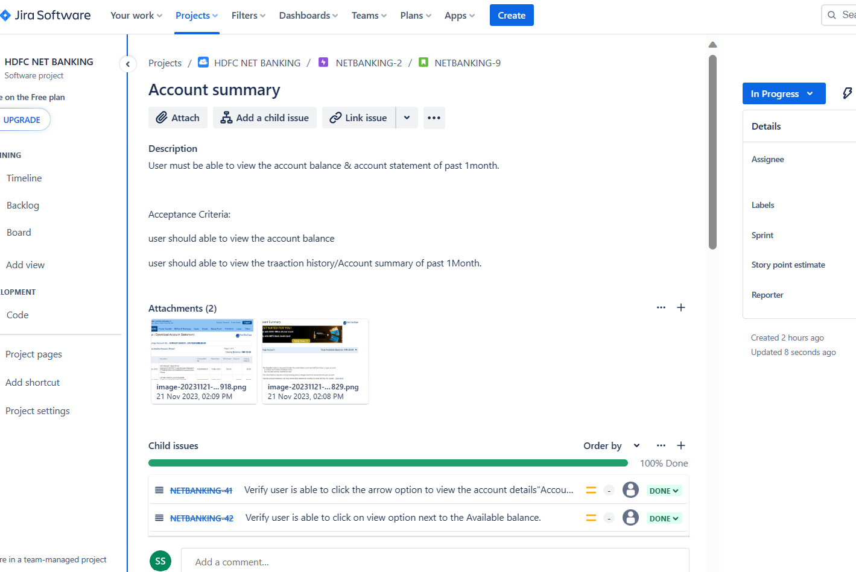

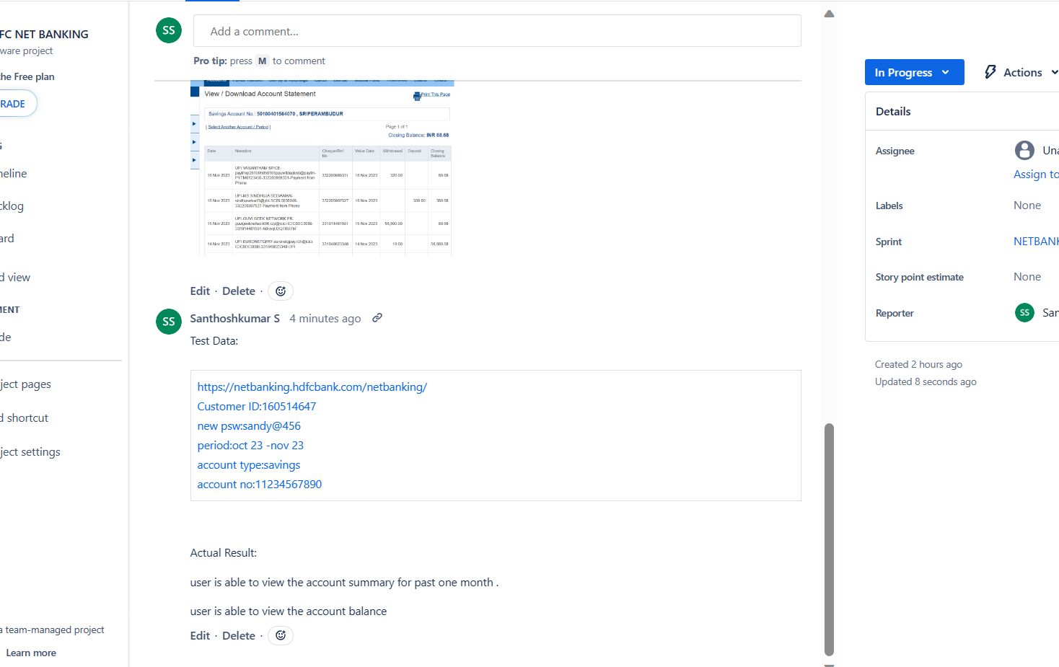

**Sprint2:NetBankSprint2-Complete Sprint**

**EPIC2: Account Summary**

**User Story4: Account Summary**

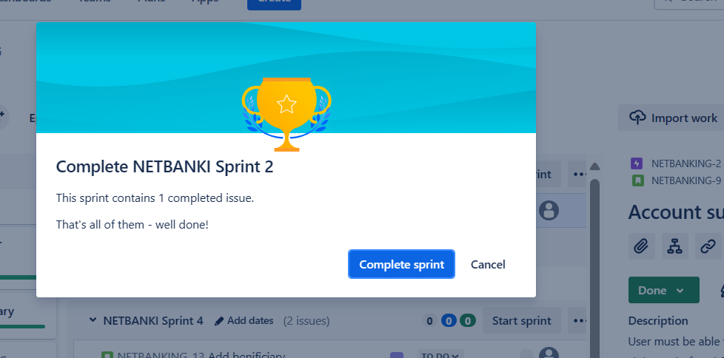

**Sprint4:NetBankSprint4-Start Sprint**

**EPIC4: FUND Transaction**

**User Story8: Add beneficiary**

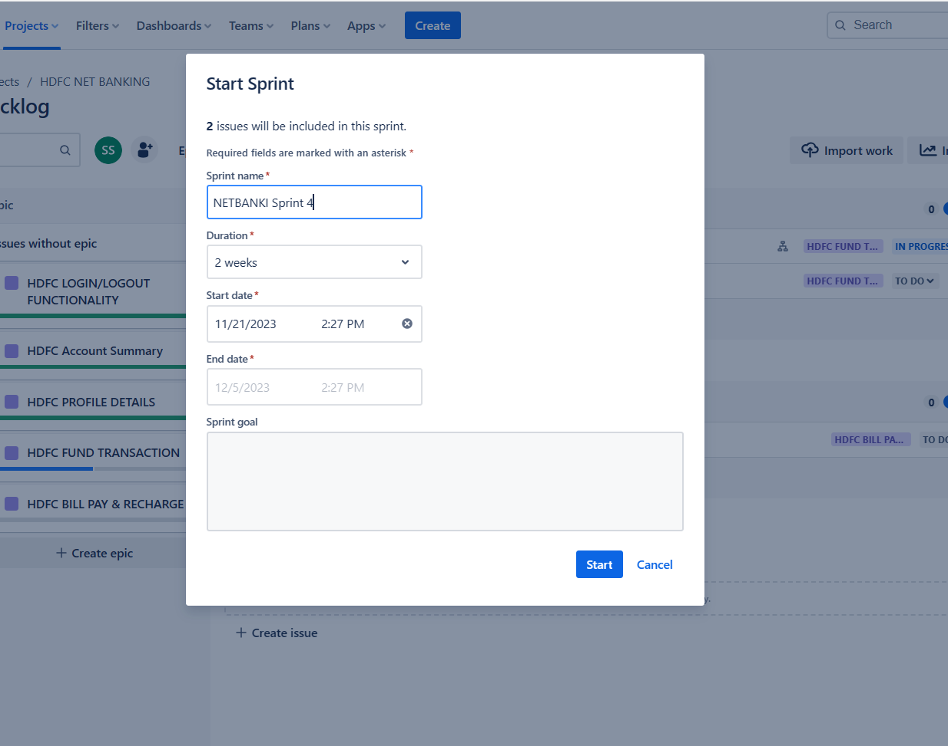

**Evidence1:**

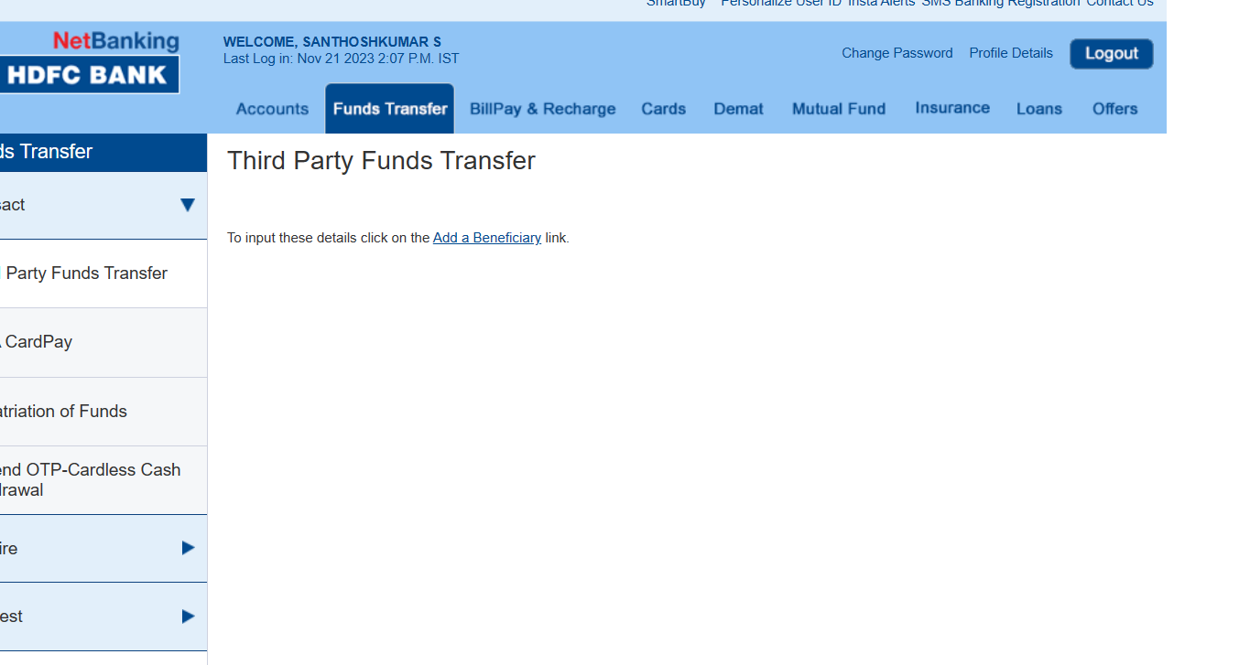

**Evidence2:**

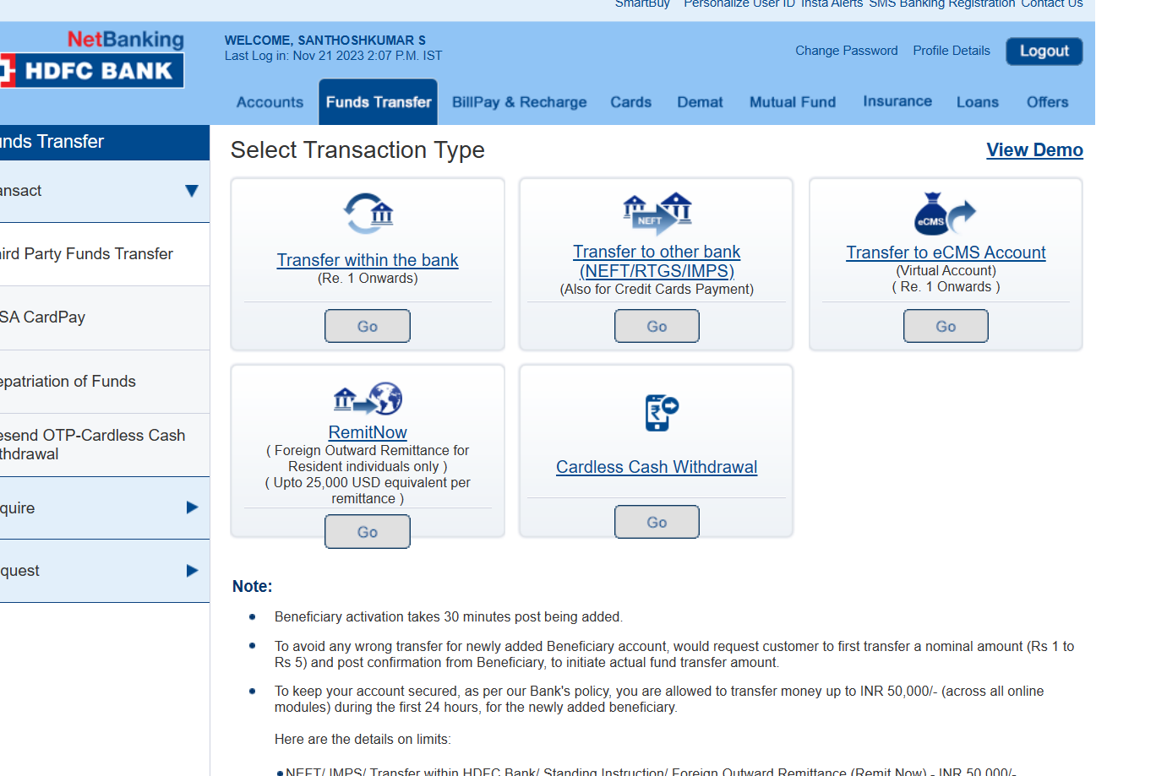

**Evidence3:**

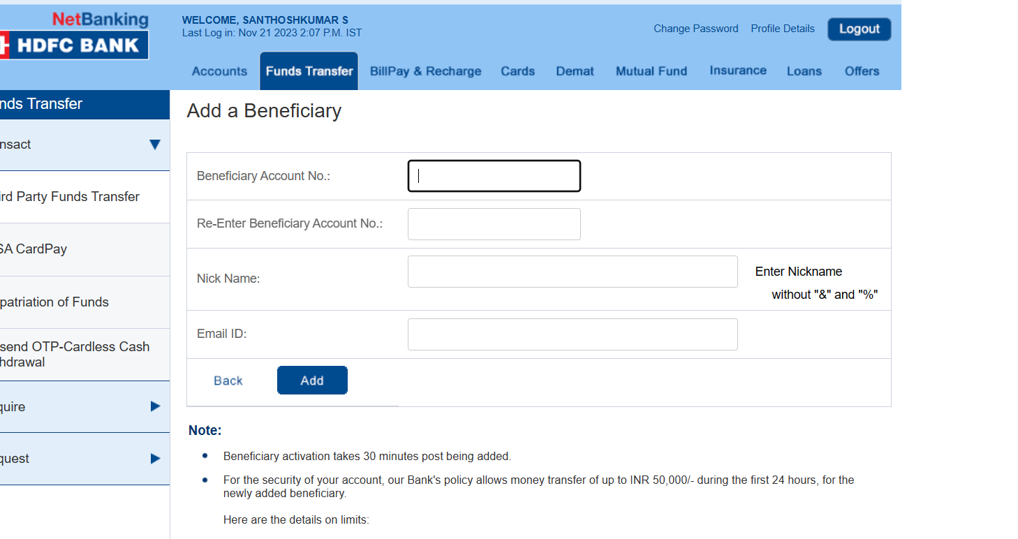

**Sprint4:NetBankSprint4**

**EPIC4: FUND Transaction**

**User Story8: Add beneficiary**

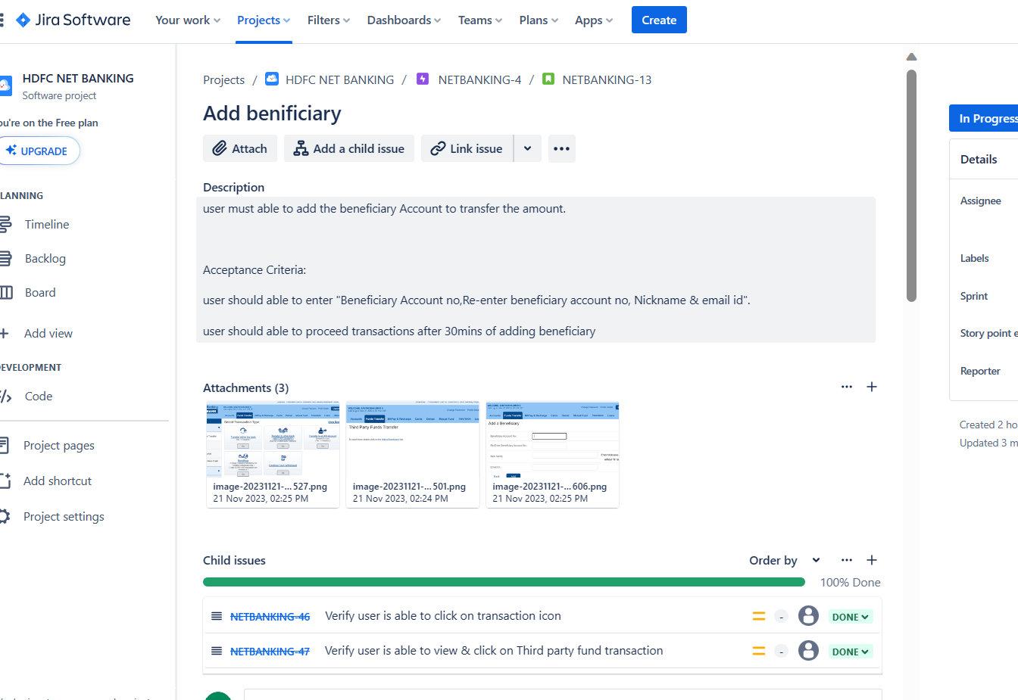

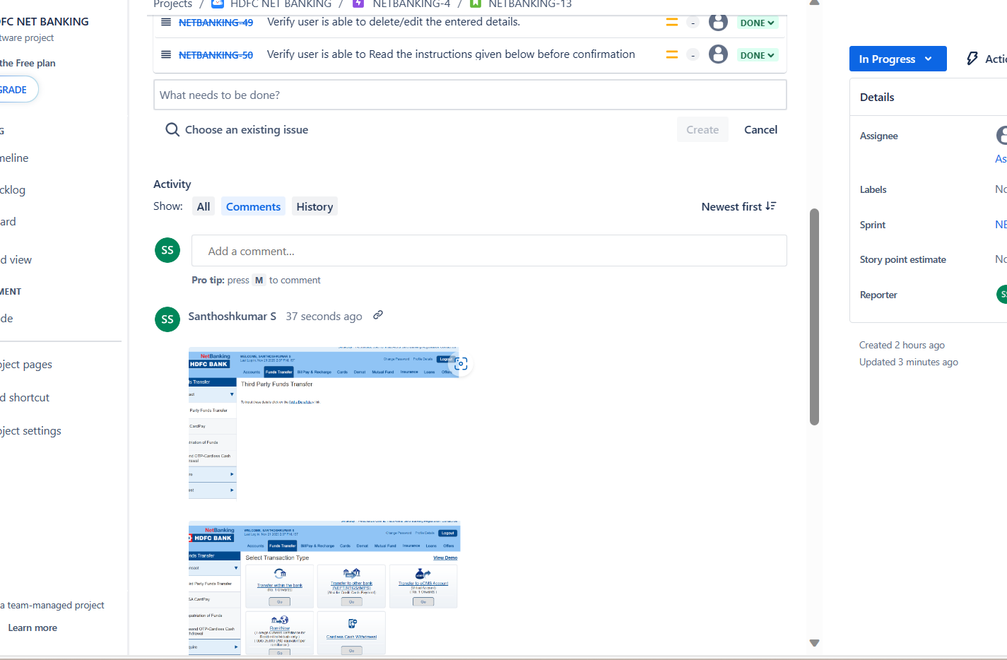

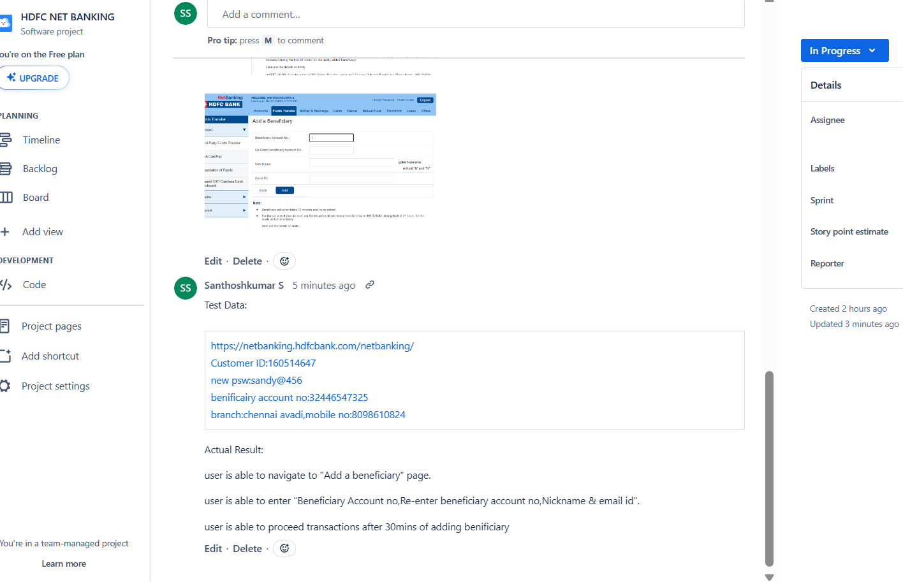

**Sprint4: NetBank Sprint4**

**EPIC4: FUND Transaction**

**User Story9: Third Party Fund Transfer**

**Evidence1:**

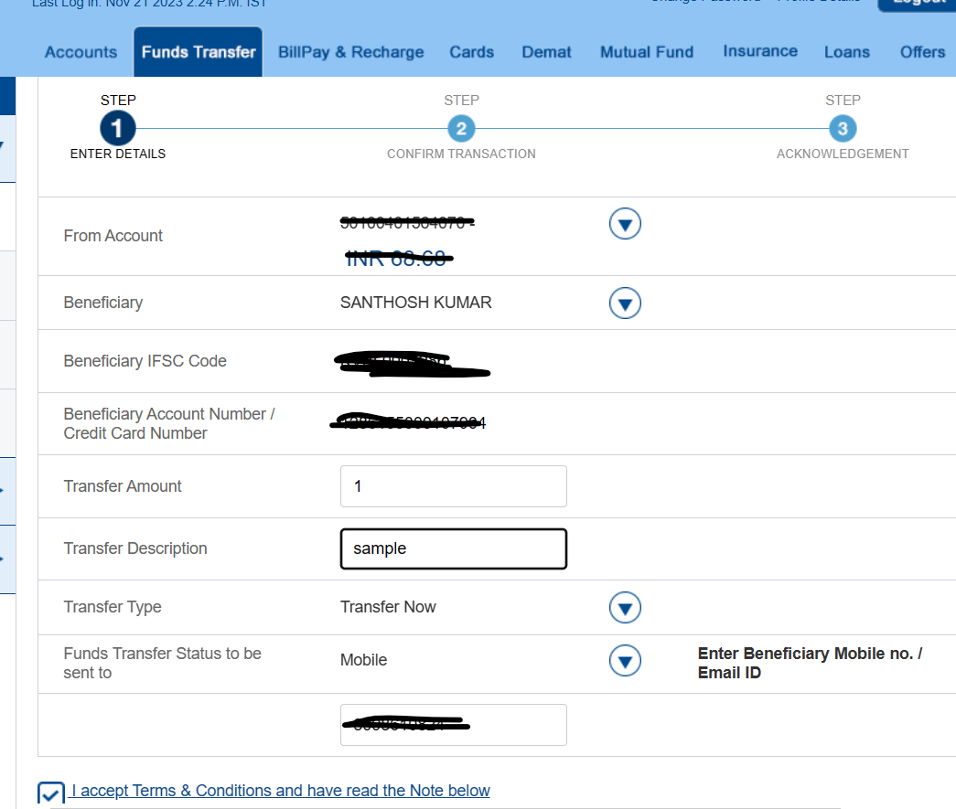

**Sprint4: NetBank Sprint4**

**EPIC4: FUND Transaction**

**User Story9: Third Party Fund Transfer**

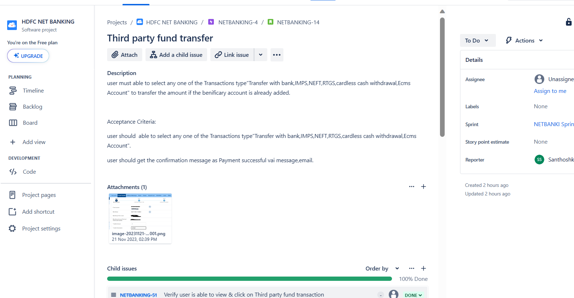

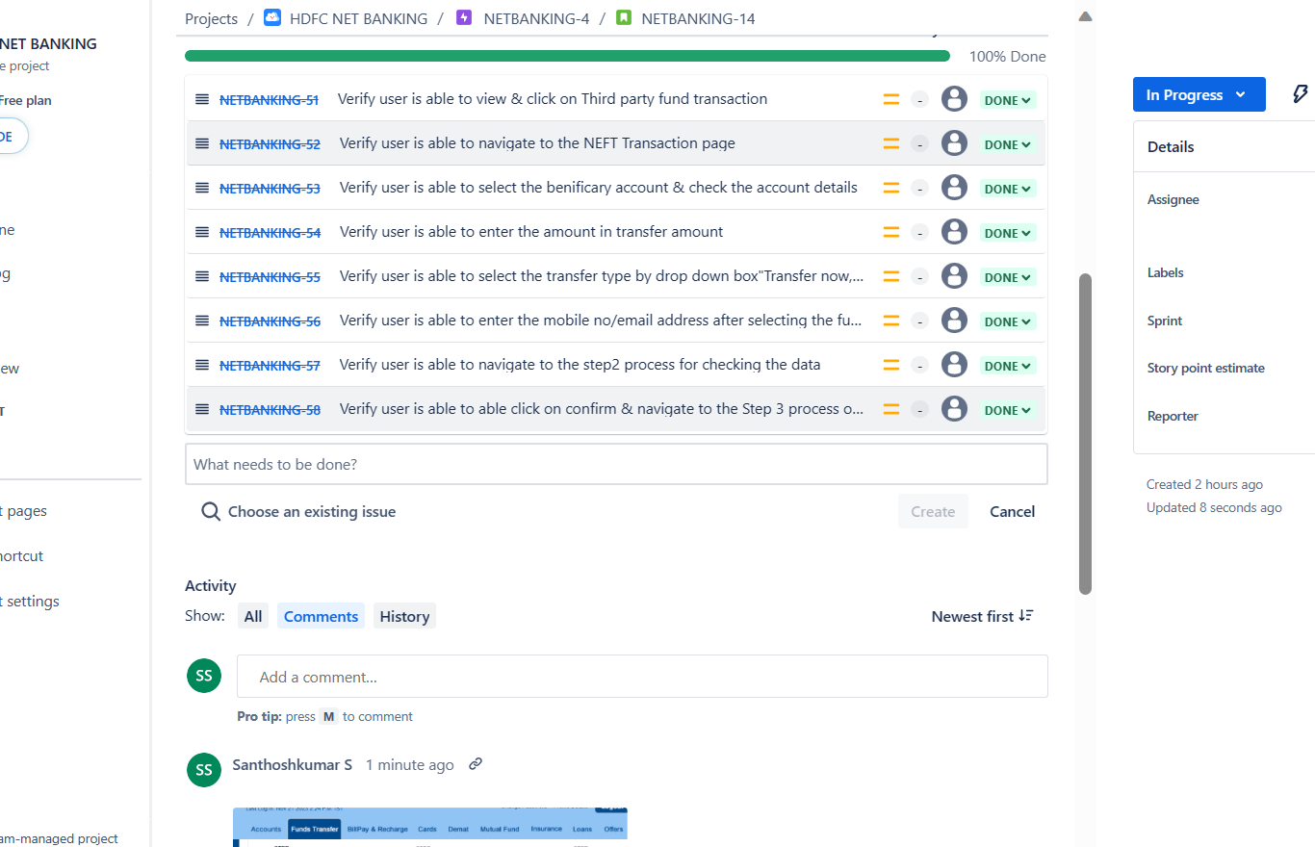

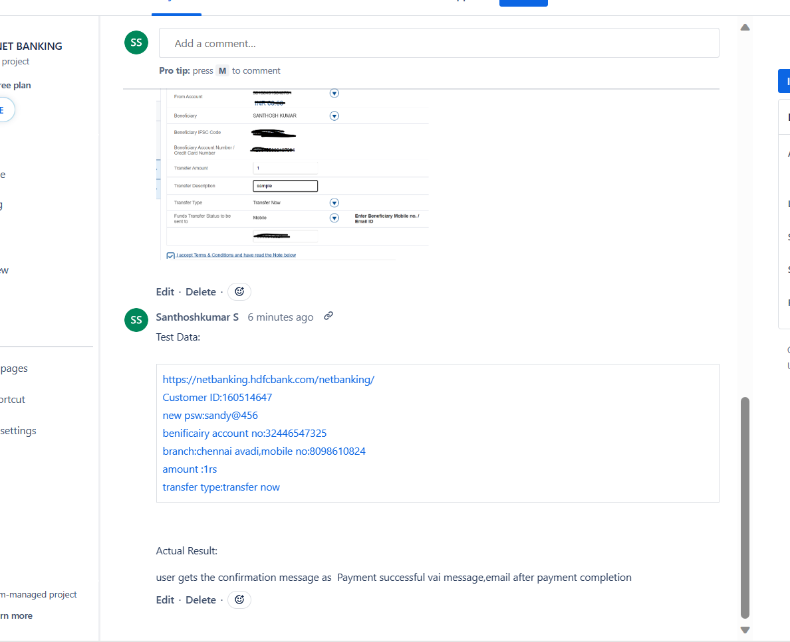

**Sprint4: NetBank Sprint4 -End of the Sprint**

**EPIC4: FUND Transaction**

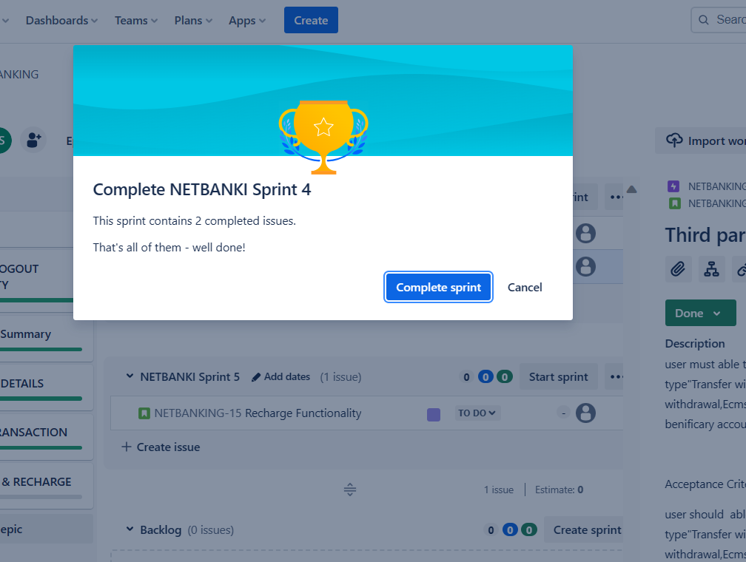

**Sprint5: NetBank Sprint5-Start Sprint**

**EPIC5: Bill Pay & Recharge**

**User Story10: Recharge Functionality**

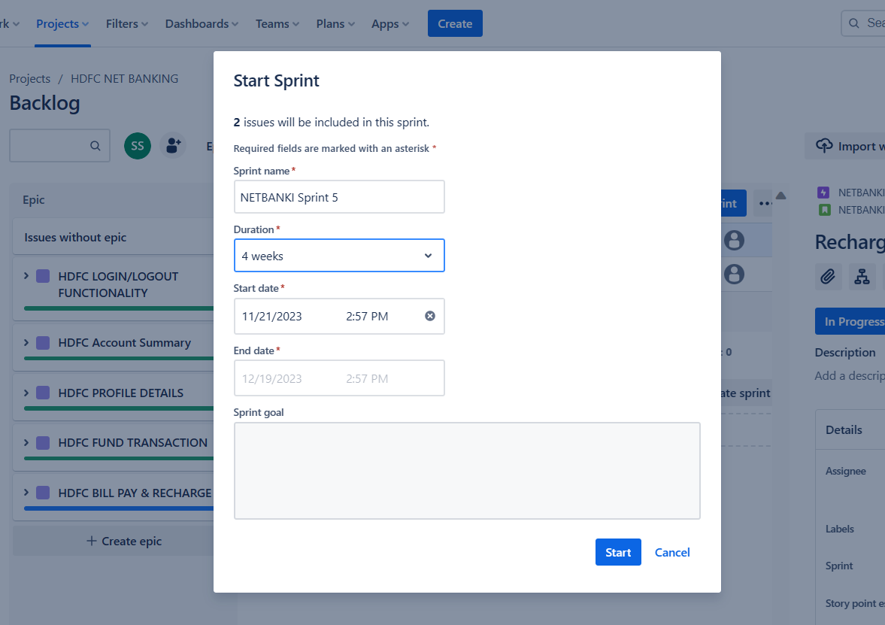

**Sprint5: NetBank Sprint5**

**EPIC5: Bill Pay & Recharge**

**User Story10: Recharge Functionality**

**Evidence1:**

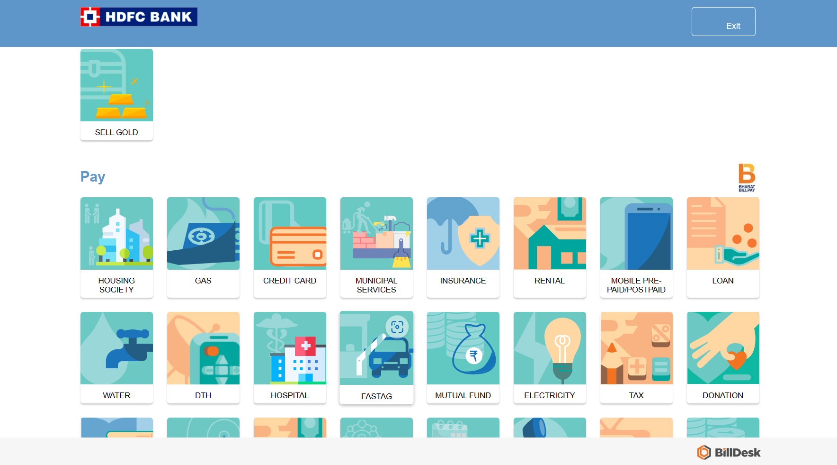

**Evidence2:**

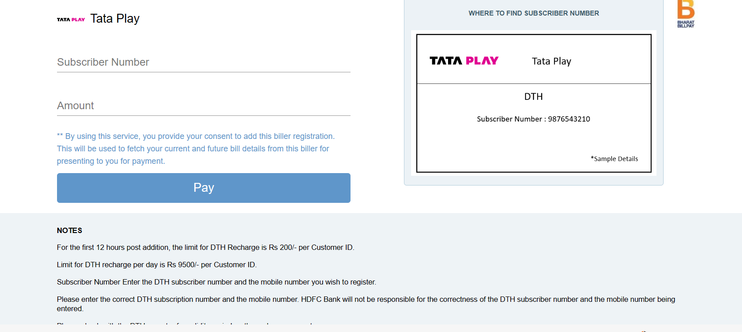

**Evidence3:**

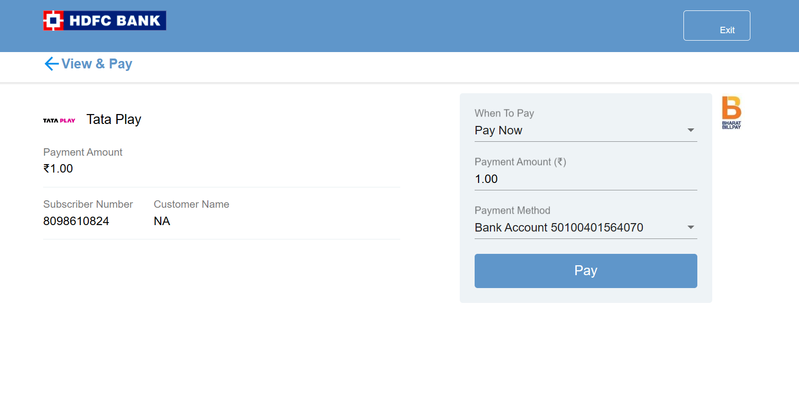

**Evidence4:**

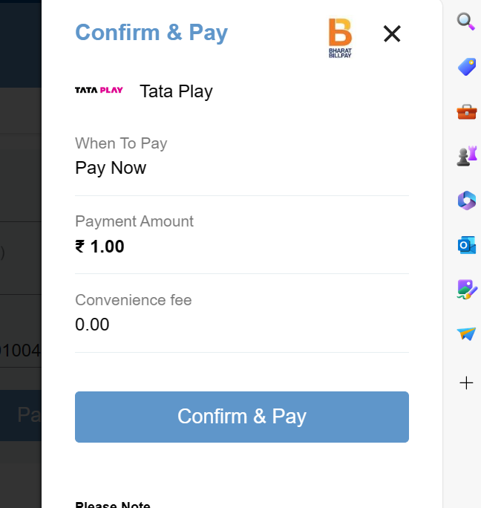

**Sprint5: NetBank Sprint5**

**EPIC5: Bill Pay & Recharge**

**User Story10: Recharge Functionality**

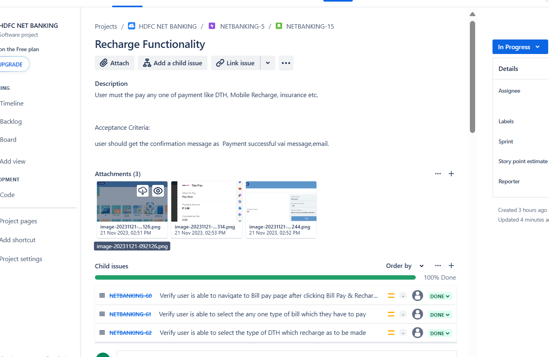

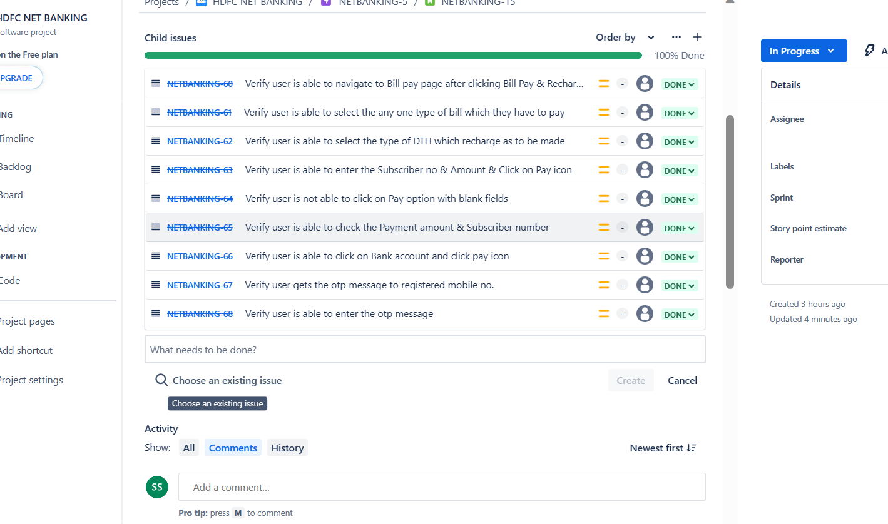

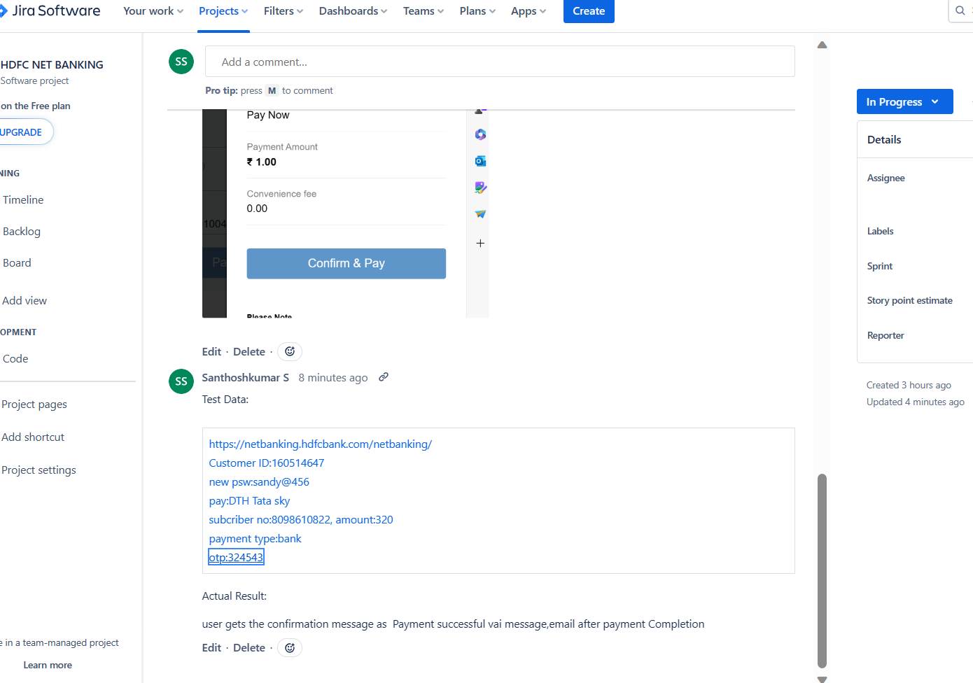

**Sprint5: NetBank Sprint5-End of sprint**

**EPIC5: Bill Pay & Recharge**

**User Story10: Recharge Functionality**

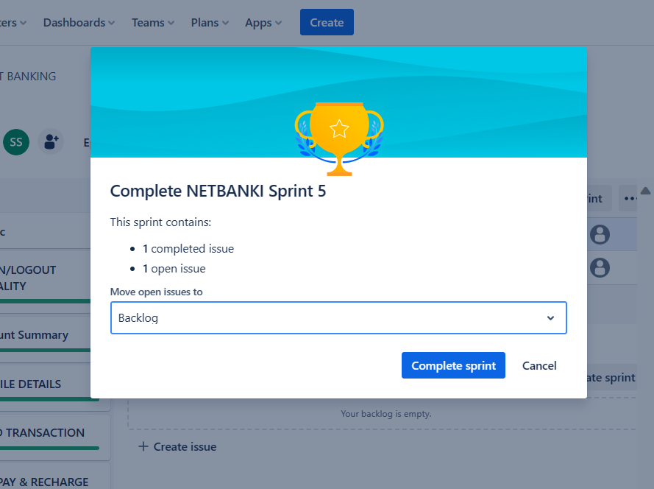

**Backlog of sprint:**

